**A Comprehensive Record Management System Promoting Accessibility and Inclusivity for Persons with Disabilities**

**A Capstone Project**

Submitted to

The Faculty of The College of Computing Studies

**PAMANTASAN NG CABUYAO**

City of Cabuyao, Laguna

In Partial Fulfillment

Of the Requirements for the Degree

**BACHELOR OF SCIENCE IN INFORMATION TECHNOLOGY**

**By:**

Carandang Jr., Richard J.

Castillano, Lovely Anne O.

Mananquil, Mel Ivan B.

Sarino, Nhoel Ivan A.

**April 2025**

Table of Contents

**Page**

Title Page i

Table of Contents iii

List of Tables v

List of Figures vi-viii

**CHAPTER I – THE PROBLEM AND ITS SETTING**

Introduction 1

Objectives 3

 General Objective 3

 Specific Objectives 3

Scope and Limitation 4

Significance of the Study 8

Definitions and Terms 11

**CHAPTER II – REVIEW OF RELATED LITERATURE AND STUDIES**

Chapter Overview 14

Conceptual Literature 14

Review of Related Literature 17

 Foreign Literature 17

 Local Literature 18

Review of Related Studies 20

 Foreign Studies 20

 Local Studies 21

Theoretical / Conceptual Framework 22

Conceptual Paradigm 24

Synthesis 25

**CHAPTER III – METHODS AND PROCEDURES**

Introduction 27

Research Design 27

Respondents of the Study 28

Data Gathering Procedure 29

Evaluation and Scoring 30

Data Analysis Plan 32

System Development 33

  Use Case Diagram 37

  Activity Diagrams 46

  Class Diagrams 112

Ethical Considerations 113

Literature Cited 114

**APPENDICES**

A. Copy of Confidentiality and Non-Disclosure Agreement

B. Validated Research Instrument/s

C. Informed Consent Form

D. Research Ethics Review Committee Evaluation

E. Short Report of Plagiarism Software

F. Report of Language Software

G. Curriculum Vitae of Student Researchers

**List of Tables**

**Page**

Table 1 Respondents of the Study 29

Table 2 Rating Scale for System Evaluation31

**List of Figures**

**Page**

Figure 1. Agile Methodology Process Flow [55] 23

Figure 2. Conceptual paradigm 24

**Use Case Diagram**

Figure 3. Use Case Diagram for Registration and 37

Profile Management Subsystem

Figure 4. Use Case Diagram for ID Renewal and 38

Issuance Subsystem

Figure 5. Use Case Diagram for Benefits Preparation and 39

Tracking Claims Subsystem

Figure 6. Use Case Diagram for Support Desk Subsystem 41

Figure 7. Use Case Diagram for Report and Analytics Subsystem 42

Figure 8. Use Case Diagram for Accessibility Subsystem 43

Figure 9. Use Case Diagram for Role-Based Access Subsystem 44

**Activity Diagrams**

 Figure 10. Activity Diagram for Registering PWD Member 46

Figure 11. Activity Diagram for Viewing PWD Application Status 47

Figure 12. Activity Diagram for Editing PWD Application 48

Figure 13. Activity Diagram for Validate PWD Application 49

Figure 14. Activity Diagram for Deleting Application 50

Figure 15. Activity Diagram for Approving PWD Application 51

Figure 16. Activity Diagram for Creating PWD ID Renewal Request 52

Figure 17. Activity Diagram for Viewing Request Status 53

Figure 18. Activity Diagram for Editing Pending Request 54

Figure 19. Activity Diagram for Deleting a PWD Renewal Request 55

Figure 20. Activity Diagram for PWD Request Verification Process 56

Figure 21. Activity Diagram for PWD ID Renewal Approval 58

Figure 22. Activity Diagram for Creating Masterlist 60

Figure 23. Activity Diagram of Creating Distribution Schedule 62

Figure 24. Activity Diagram for Updating Schedule 64

Figure 25. Activity Diagram for Deleting a Schedule 66

Figure 26. Activity Diagram for Viewing Beneficiary List 67

Figure 27. Activity Diagram for Scanning a PWD QR ID 68

Figure 28. Activity Diagram for Claiming a Benefit via QR Code 70

Figure 29. Activity Diagram for Requesting Late Claim 71

Figure 30. Activity Diagram for Viewing Entries 73

Figure 31. Activity Diagram for Editing a Complaint or Feedback 74

Figure 32. Activity Diagram for Creating a Complaint or Feedback 75

Figure 33. Activity Diagram for Viewing Analytics Dashboard 76

Figure 34. Activity Diagram for Generating Report 77

Figure 35. Act Diagram for Exporting a Daily Report 79

Figure 36. Activity Diagram for Exporting Monthly Report 81

Figure 37. Activity Diagram for Exporting Demographic Report 83

Figure 38. Activity Diagram for Deleting Report 84

Figure 39. Activity Diagram for Exporting Report 86

Figure 40. Activity Diagram for Applying Filter 88

Figure 41. Activity Diagram for Viewing Accessibility Settings 89

Figure 42. Activity Diagram for Updating Accessibility Preferences 90

Figure 43. Activity Diagram for Resetting Preferences to Default 91

Figure 44. Activity Diagram for Accessing the System Interface 92

Figure 45. Activity Diagram for Controlling Data Access 93

Figure 46. Activity Diagram for Creating User Account 95

Figure 47. Activity Diagram for Deleting User Account 97

Figure 48. Activity Diagram for Disabling User Account 98

Figure 49. Activity Diagram for Monitoring Security 99

Figure 50. Activity Diagram for Resetting a User Password 101

Figure 51. Activity Diagram for Restricting a User Data Access 102

Figure 52. Activity Diagram for Searching Data 104

Figure 53. Activity Diagram for Setting User’s Roles 106

Figure 54. Activity Diagram for Updating User Account 107

Figure 55. Activity Diagram for Viewing Activity Log 109

Figure 56. Activity Diagram for Viewing Activity Log 110

**Class Diagrams**

Figure 57. Class Diagram for PWD Management System 112

CHAPTER I

THE PROBLEM AND ITS SETTING

# Introduction

# The growing demand for efficient public services has made digital transformation essential in the public sector. The Persons with Disabilities (PWD) Office of Cabuyao City faces increasing pressure to update its operations. It needs to provide faster, more accurate, and more accessible services to its beneficiaries. However, the office still relies on a paper-based system for all its core functions. These include registration, ID issuance and renewal, benefit tracking, complaint handling, and barangay coordination.

# Currently, the PWD Office processes an average of 30 to 50 transactions each day, totaling roughly 1,000 to 1,500 transactions each month. These daily transactions include new registrations, ID issuance, ID renewals, and a range of complaints related to issued IDs such as incorrect name spellings, mismatched birthdates, or inaccurate listings of disability types. Other transactions involve benefit claims, follow-ups, and barangay verifications. During peak periods such as national registration drives daily transactions can spike to over 70. These high volumes often lead to long queues, delays, and increased workloads for the staff. Without a digital system, the office struggles to track workloads accurately, such as how many IDs were issued, how often benefits are claimed, or which barangays generate the most activity. This lack of centralized data makes it challenging to enhance processes, allocate resources efficiently, and track performance over time.

# Interviews and surveys with office staff and PWD members highlight several ongoing issues tied to the manual system. Staff fill out registration forms by hand, and records are kept in filing cabinets. This slows down processing and increases the risk of data loss or duplication. One major issue is related to ID issuance. Errors such as misspelled names, incorrect birthdates, or missing information often lead to repeated ID reprints, which cause delays for beneficiaries and add to the administrative burden. The

# manual benefit tracking system also fails to verify whether a member has already claimed a service, potentially resulting in unclaimed benefits or unintended duplicate distributions.

# The challenge grows larger considering the increasing PWD population in Cabuyao City. To date, over 7,000 individuals have been officially registered, representing more than 8,800 recorded cases of disability. Many individuals have multiple impairments. Disabilities range from physical and orthopedic issues to psychosocial conditions, sensory impairments, intellectual disabilities, cancer (RA 11215), and rare diseases (RA 10747). Demographically, around 52.4% of registrants are male, while 47.6% are female. This information is crucial for designing inclusive services and outreach efforts.

# To address these operational and data-related challenges, this study proposes developing a Comprehensive Record Management System (CRMS) tailored for the PWD Office of Cabuyao City. This digital platform will centralize and automate core functions such as profile registration, ID issuance and renewal, benefit tracking, complaint management (including ID corrections), barangay coordination, and analytics reporting. The CRMS will feature mobile responsiveness, assistive technology compatibility (e.g., screen readers like NVDA), and multilingual support to cater to diverse user needs. Role-based access control will ensure secure and structured workflows for PWD office staff, barangay representatives, and registered members.

# Additionally, the system will support online document submission and editing, along with automated email alerts, reminders, and announcements. Advanced data analytics will allow staff to monitor daily transaction volumes and detect service trends. A robust data archiving system will protect institutional records, while filterable and printable databases will support informed decision-making and reporting.

# By addressing the inefficiencies of paper-based workflows, the CRMS will empower office staff to work more efficiently and allow leadership to make proactive, data-driven decisions for better service delivery.

# Objectives

General Objective:

To design, develop, and implement a Comprehensive Record Management System for the PWD Office of Cabuyao City that modernizes operational workflows, strengthens data security, improves service accessibility, and promotes inclusive governance.

Specific Objectives:

1. **Determine the current practices and problems encountered by the PWD Office of Cabuyao in terms of:**
   1. Manual recording and handling of registration;
   2. Delays and errors in ID issuance and renewals;
   3. Paper-based benefit preparation and tracking;
   4. Lack of a dedicated system to receive and track member concerns
   5. Maintaining, filtering, and updating records across barangays;
   6. Time-consuming paper-based data processes;
   7. Role-based access controls for safe data access are absent.
2. **Determine how the proposed CRMS would help the PWD Office of Cabuyao in such a way that it would provide:**
   1. An online registration management system for faster, more accurate processing of member profiles;
   2. A computerized ID issuance system with notification alerts for new and renewal processes, reducing reprint errors;
   3. A benefit tracking system that includes preparation of document requirements before benefit distribution and uses QR codes on PWD IDs for fast, secure claim verification, with features to generate a master list of beneficiaries for each scheduled release.
   4. A built-in PWD support desk module that allows members to submit concerns and receive status updates online;
   5. A centralized record system with reporting and analytics for data consolidation, demographic insights, and informed decision‑making;
   6. A user-friendly CRMS with a screen reader-compatible (e.g., NVDA) and multilingual interface to ensure accessibility and paperless workflows;
   7. Introduce a role-based access control for Admins, Barangay Presidents, and Members to secure data and streamline operations.
3. **Evaluate the performance of the proposed system for users based on the following criteria ISO 25010 Software Quality Standards:** 
   1. reliability;
   2. functional suitability;
   3. interaction capability; and
   4. performance efficiency.
4. **Evaluate the performance of the proposed system for IT Experts based on the following criteria of ISO 25010 Software Quality Standards:**
   1. security;
   2. maintainability;
   3. compatibility;
   4. flexibility; and
   5. performance efficiency.

**Scope and Limitation**

# This study aims to develop a Comprehensive Record Management System (CRMS) that caters specifically to the Cabuyao City Persons with Disabilities (PWD) Office. The system aims to replace the current manual paper-based procedures with a centralized, secure web-based platform to enhance the effectiveness and precision, and accessibility of PWD-related services and data management. The CRMS provides inclusive service delivery through accessibility features while automating essential administrative tasks.

The Registration and PWD Profile Management module enables the PWD Office and barangay officials to manage member profiles, registrations, and approvals through an online system. It eliminates the need for paper forms by allowing persons with disabilities to submit their applications digitally. Once a member registers online, the application is first sent to the Barangay PWD President, who verifies the validity and completeness of the submitted requirements. If the documents are in order, the Barangay PWD President forwards the application to the PDAO Office for final verification. After the PDAO Office verifies the submitted documents, it will notify the applicant using the system to proceed to the office for an in-person disability assessment. During this assessment, the applicant’s condition is evaluated to confirm if they are eligible for official PWD status. Once approved, they will simply wait for a notification through their account in the system, informing them that their PWD ID is ready for claiming.

# ​The ID Issuance and Renewal module helps avoid routine errors in the accuracy of personal information by utilizing digital profiles that automatically populate member details, ensuring efficient and accurate generation of PWD identification cards. To support timely renewals, the system provides automatic reminders to notify members of their upcoming renewal dates, reducing the need for repeated administrative follow-ups and unnecessary reprints. Specifically, for ID renewal, the system first notifies the PWD member 30 days before the scheduled renewal date. When the user logs in to their account, a pop-up notification appears on their dashboard, reminding them to renew their ID on or before the assigned date. The user can then navigate to the PWD ID section of their dashboard to submit a renewal request. Once submitted, the PDAO staff will verify the request and notify the user through the system if everything is in order. After verification, the ID will be processed, and within 2–3 days, the system will send another notification informing the member that their renewed PWD ID is ready for claiming. The 2–3 day window allows time for the Department of Health (DOH) to verify and validate the submitted documents, ensuring that all requirements are met before the ID is officially released. For updating or correcting information, the same process applies, allowing users to submit requests through their dashboard, which are then verified and approved by the PDAO staff before the updated ID is issued.

# The Benefit Preparation and Tracking system manages the entire process of recording, verifying, and processing benefit claims for registered PWD members. It automates the creation of the master list of beneficiaries, prepares the payroll, and generates the official request letter for approval. Once approved, the system requires the uploading of necessary documents. After the documents are uploaded and validated, the barangay event or program schedule is created through the admin’s account. The admin then posts an announcement about the program, setting the date and venue, and sends a notification to the barangay president through the system. This announcement is visible only to the Barangay president’s account, allowing them to inform all registered PWD members via their Member Dashboard.

# On the day of distribution, the system updates benefit statuses in real time by scanning the beneficiaries’ QR Codes, ensuring accurate verification and preventing duplicate claims. It also handles late-claim requests, wherein PWD members are required to request an official letter either through their PWD Member accounts or in person at the PDAO main office. This letter is then submitted and presented to the Treasury Department for benefit release. Once the letter is signed and the benefit is claimed, the admin will scan the signed letter, upload it to the member’s data archive, and update the PWD member’s claim status in the database.

# This automated workflow applies to both the quarterly Birthday Cash Gift and the monthly Financial Assistance programs from beneficiary list creation to approval, distribution, and reporting, minimizing manual work and ensuring transparency.

# A Complaints and Feedback Management comes equipped with an integrated PWD Support Desk. The users submit grievances, comments, or requests for help online; they even get updates on the status. This enhances communication between office staff and the PWD community. The office responds graciously while keeping members satisfied.

The Barangay Coordination Module provides PWD barangay presidents with limited administrative privileges to manage local PWD records, verify registrations, and post barangay-specific announcements. The system automates record verification by cross-checking new entries with the central database to prevent duplication and ensure data accuracy. Barangay officials can update member profiles, track changes in real time, and monitor participation statistics for their jurisdiction.

This module also manages the creation and scheduling of events or programs initiated by the PDAO or Municipal Office. It automatically generates the participant master list, prepares budget request letters, and routes them for approval using the same workflow as the benefit tracking system. The system can filter the master list to target specific disability groups or barangays, ensuring precise participant selection and resource allocation.

# The Reports and Data Analytics feature offers extensive monitoring and examination of the activities of the PWD Office. Aside from monitoring registration numbers, issuances of IDs, renewals, claims of benefits, and complaints processed daily and summed up by the month, it also provides detailed information on day-to-day and monthly transactions. An updated master list of Cabuyao City registered PWD members is also stored in the system; it is filterable by barangay and by type of disability, such as physical, sensory, intellectual, psychosocial, cancer (RA 11215), and rare diseases (RA 10747). The office can understand service requirements and demographic breakdowns in different parts of the country and among different disability categories due to this filtering function. To enable staff and leadership to inform their decisions with data, efficiently allocate resources, and design targeted outreach initiatives, transaction patterns, peak usage periods, and barangay-specific information are distilled in graphical dashboards and print-ready reports. The accuracy and completeness of data provided by barangay officials and staff determine the quality of analytics.

# Accessibility is considered throughout the system, which supports a multilingual interface, mobile responsiveness, and assistive technology accommodations such as NVDA screen readers. By ensuring that PWD members with varying abilities can use the system seamlessly, these capabilities create inclusiveness. Unlike native applications, the system currently lacks a specific mobile app, which could limit mobile functionality.

# A role-based access control (RBAC) framework to protect confidential information. For the protection of privacy, data integrity, and the acceleration of processes, PWD Office Administrators, Barangay Presidents, and PWD Members are allocated different levels of access. To prevent unauthorized data disclosure, this organization calls for strict compliance with security policies and regular access audits.

This study's limitations do not cover the actual financial transaction processes, such as the distribution of financial aid and birthday cash gifts. The actual release of funds remains under the responsibility of bonded personnel from the City Treasury Department. The system does not manage any form of direct financial distribution and is limited to tracking purposes only. Additionally, although the PWD Office may conduct programs supported by municipal funding, the responsibility of managing and disbursing the allocated budget for such programs will be handled by the PWD Office itself. It does not handle logistics for educational or outreach activities. Any official record changes or incident reports that require Department of Health (DOH) approval must still be processed manually. The system relies on a stable internet connection to function effectively, which may limit usability in areas with poor internet access. Its effectiveness is also dependent on active collaboration from barangay presidents and personnel, particularly during the registration and verification process. Lastly, the system does not offer a native mobile application, which may reduce accessibility for users who rely solely on mobile devices.

# Significance of the Study

This research is significant because it directly speaks to the operational challenges with which Cabuyao City's Persons with Disabilities (PWD) Office currently struggles since it has inefficient, paper-based processes. These manual flows adversely affect the provision of services to PWD constituents by causing errors, delays, and difficulties in managing and analyzing data. The Comprehensive Record Management System (CRMS) will streamline office processes through the creation of a centralized, secure, and easy-to-use digital portal that simplifies registration, ID issuance, benefit tracking, complaint handling, and barangay coordination. Role-based access control, barangay and disability-type-filtered reports, and advanced data analytics for monitoring transactions on a daily and monthly basis improve decision-making, resource allocation, and participative governance.

For the **Barangay Presidents**, the system provides limited administrative access that enables them to verify local registrations and manage barangay-specific announcements. They also play a key role in coordinating PWD Office-led events and programs by helping disseminate information and tracking participant attendance. Each event features a QR code-based attendance system, where registered members simply scan their PWD IDs upon arrival, ensuring accurate and real-time recording of participation. This promotes punctual and correct data submission, which is essential for maintaining an up-to-date master list and generating reliable analytics. Overall, this feature strengthens coordination at the community level and supports more organized and responsive program implementation.

More generally, the system's rigorous role-based access control significantly enhances data privacy and security by effectively alleviating issues with uncontrolled access inherent in the current manual procedures. For the purpose of ensuring that users enjoy a stable and user-friendly platform, the system's design also places emphasis on dependability, functional suitability, and interaction capability. To facilitate prompt, secure transactions and effective interaction for PWD members and workers alike, performance efficiency and security are accorded utmost importance. The system, though, is aware of its limitations, indicating areas for enhancement, including its dependency on reliable internet connectivity and absence of bundled financial transaction processing.

For **Future Researchers,** improving system maintainability, compatibility, and flexibility all the important elements for adapting to evolving technological landscapes sets the stage for future developments. Potential areas of study for future research would include applying sophisticated predictive analytics towards proactive service management, consolidating financial modules for efficient benefit distribution, and incorporating mobile apps to enhance accessibility. Applying blockchain technology for enhanced data safety and expanding support for assistive and multilingual tech for greater inclusiveness are two other new areas. The aim of this ongoing system enhancement process is to create more robust, transparent, and efficient public service platforms.

For **PWD members**, with an easy-to-use, multilingual system that is accessible to assistive technology such as NVDA screen readers, the CRMS streamlines service access. Members can actively participate in their service management via automated ID renewal reminders and a feedback mechanism, which reduces the administrative burden and lapses inherent in the manual system.

For **PWD Office administrators and staff**, the system facilitates faster and more accurate processing of registrations and transactions, reducing errors in benefit claims and ID issuance. A support desk module improves communication with PWD members, while real-time information and automated alerts contribute to operational efficiency. The system directly addresses long-standing issues such as manual record handling, delays, and the lack of verifiable benefit tracking. Additionally, the integration of report analytics allows staff to generate timely and detailed reports on transactions, benefit distributions, and overall service utilization. These insights support better decision-making and resource allocation. The mission of this study to promote inclusivity is further supported by the system’s mobile-friendly design and compatibility with assistive technologies, ensuring that services are accessible to a broader and more diverse group of PWD members.

For **researchers**, this study is an illustration of how practical application of ISO 25010 software quality standards can be utilized to evaluate a digital solution for the vulnerable members of the public sector. To ensure a system that is efficient and simple to use, it outlines how elements such as dependability, functional suitability, interaction capability, security, and performance efficiency can be evaluated from the perspective of the end user. This study offers extensive coverage of the technical quality and sustainability of the system by looking deeper into security, maintainability, compatibility, flexibility, and performance efficiency from an IT expert point of view. Such evaluations contribute substantial information to the fields of digital public service reformation and inclusive e-governance in local government institutions.

Overall, this study is a testament to Cabuyao City's vision for inclusive governance by bringing a technological solution that enhances the efficiency, security, and accessibility of services to PWD constituents, as well as empowering employees and leadership with data-driven analytics to make more informed decisions.

# Definitions and Terms

**Accessibility –** The ease with which authorized personnel can retrieve, update, and manage PWD records [52].

**Archiving –** The process of preserving important documents and records for long-term storage and future reference. In the proposed system, archiving ensures data retention and compliance with information management standards [57].

**Assistive Technology –** Equipment, software, or tools that help persons with disabilities perform functions that might otherwise be difficult. Example: screen readers [58].

**Automation –** The application of technology to monitor and control the production and delivery of products and services, reducing human intervention and increasing efficiency [50].

**Compliance –** Adherence to legal and policy requirements for handling PWD data securely and efficiently [53].

**Comprehensive Record Management System –** A digital platform designed to automate and streamline the PWD Office's core operations, including registration, service tracking, complaints management, and reporting [59].

**Dashboard –** A user interface that organizes and presents information in a way that is easy to read and interpret. The dashboard in this study displays real-time data about PWD registrations, services, and system activities [61].

**Data Analytics –** The process of examining, interpreting, and visualizing data to generate insights and support informed decision-making. In this study, descriptive analytics is used to monitor service usage, complaints, and demographic trends among PWDs [65].

**Data Integrity –** The assurance that data is accurate, consistent, and safeguarded from unauthorized modification or corruption throughout its lifecycle [60].

**Data Security –** The implementation of protective measures to prevent unauthorized access, alteration, or destruction of data, ensuring the confidentiality, integrity, and availability of information [48].

**Digitalization –** The process of converting analog or paper-based records into digital formats to enhance accessibility, storage, and operational efficiency in data management [47].

**ISO 25010 –** An international standard that defines a quality model for evaluating software products based on characteristics such as compatibility, reliability, usability, maintainability, and security [62].

**Multilingual Support –** A system feature that allows users to select and interact with the system in different languages, enhancing inclusivity and usability for a diverse population [63].

**Persons with Disabilities (PWDs) –** Individuals who have long-term physical, mental, intellectual, or sensory impairments which, in interaction with various barriers, may hinder their full participation in society on an equal basis with others [64].

**PWD Office –** A government office managing records, benefits, and services for persons with disabilities [51].

**QR Code –** A two-dimensional barcode that can hold information like text, links, or identification numbers. QR Codes in this research are incorporated into PWD identification cards and utilized to speedily authenticate and monitor member transactions or benefit claims by scanning the code through a device, allowing fast and precise data retrieval [66].

**Record Management System (RMS) –** A systematic approach to the creation, organization, maintenance, and disposal of records, enabling efficient retrieval and secure storage of information [46].

**Role-Based Access Control (RBAC) –** A security model that assigns system access permissions based on a user’s role within an organization, limiting access only to information necessary for performing specific job functions [49].

**Service Efficiency –** Improving administrative processes to deliver faster and more accurate PWD-related services [54].

CHAPTER II

REVIEW OF RELATED LITERATURE AND STUDIES

# Chapter Overview

This chapter presents a review of related literature and studies that underpin the development and enhancement of the proposed Comprehensive Record Management System for the PWD Office of Cabuyao City. It focuses on key areas essential to modernizing and streamlining operations, including effective system functionality, robust data management, improved service delivery, and user accessibility. The review covers best practices and technological frameworks relevant to core system modules such as PWD Profile Management, Registration and ID Issuance, Benefits and Services Tracking, Accessibility Needs Documentation, Complaints and Feedback Handling, Real-Time Dashboard Monitoring, and Data Archiving. Insights gained from existing research will guide the design and implementation of an inclusive, efficient, and secure digital platform tailored to the unique requirements of the PWD community in Cabuyao City.

# Conceptual Literature

The Comprehensive Record Management System (CRMS) for Persons with Disabilities (PWDs) aims to improve the accessibility, compatibility, and security of managing PWD records. Many government offices still rely on manual, paper-based processes, leading to inefficiencies, data inaccuracy, and delays in service delivery [16]. These issues hinder PWDs from accessing their records and benefits efficiently. Implementing a digital record management system ensures accurate record-keeping, faster processing times, and improved coordination among government staff, ultimately enhancing service quality and inclusivity [19].

A well-structured PWD record management system must address critical operational aspects, including PWD Profile Management, Registration and Issuance of IDs, Services and Benefits Tracking, Complaints and Feedback Management,

Dashboard Monitoring, and Archiving. As stated in [19], digitizing these modules significantly streamlines processes and enhances service transparency, clinical observations and supplemental details required for in-hospital documentation, submitting these forms digitally for easy access and future use [21][22].

According to CBM Global (2023), a well-organized digital record system enhances service delivery by reducing administrative workload and improving data accuracy [4]. A centralized database allows staff to retrieve and update PWD records efficiently, ensuring all information remains current and accessible. Additionally, real-time updates enable tracking changes in a PWD’s benefits, medical needs, and government assistance eligibility, facilitating better interdepartmental coordination and reducing service delays [4].

Another essential feature of the system is automated benefits tracking and computation. Many government offices struggle with tracking and distributing financial aid or social benefits manually, leading to calculation errors and disbursement delays. By automating this process, the system efficiently computes the total benefits received by each PWD, ensuring transparency and fairness [6]. Additionally, the system generates real-time reports on benefit allocations, which government agencies can use for policy-making and resource planning [11].

Since PWD records contain sensitive personal and medical information, data security and privacy are paramount. The system must implement strong encryption methods to protect PWD data from unauthorized access during transmission and storage. Additionally, role-based access control (RBAC) ensures that only authorized personnel can modify or access certain records, minimizing the risk of data breaches. Compliance with data privacy laws, such as the Data Privacy Act of 2012 in the Philippines, reinforces patient trust by safeguarding their personal information [53].

Beyond record management and security, data analytics and reporting tools enhance decision-making by providing valuable insights into PWD demographics, benefits distribution, and service utilization. By integrating data visualization tools, administrators can analyze trends and identify areas that require attention, ensuring that resources are allocated efficiently to support the needs of PWDs [14].

The development of the PWD record management system follows an Agile software development methodology, allowing for continuous improvements and quick adjustments based on user feedback [55]. By working closely with PWD Office staff and stakeholders, developers ensure that the system remains user-friendly and accessible. The system is designed with a modular architecture, enabling individual components such as record management, appointment scheduling, and reporting to function independently. This design improves scalability and maintainability, making it easier to integrate new features in the future [15].

For the backend development, secure and scalable frameworks such as Laravel (PHP) and Nest.js (TypeScript) are considered. Laravel provides a structured and efficient environment for authentication, database management, and routing [16][22], while Nest.js offers a TypeScript-based backend solution for building scalable applications [31]. Both frameworks ensure high performance, security, and maintainability [22].

For the frontend development, React.js is used due to its component-based structure, which enables the creation of reusable UI elements. This approach enhances the flexibility and responsiveness of the user interface, ensuring that the system remains accessible to individuals with disabilities [13].

A strong focus on testing and quality assurance is also essential. Unit testing verifies the functionality of individual components, while performance testing ensures that the system can handle large amounts of data efficiently. The iterative and flexible nature of Agile development allows developers to make quick adjustments based on user feedback, ensuring that the system remains reliable and user-friendly over time [3].

Furthermore, Universal Design principles advocate for the integration of assistive technologies and mobile responsiveness, making platforms accessible to users with different needs [58]. Incorporating multilingual support also ensures inclusivity in service access [63]

# Review of Related Literature

Foreign Literature

A PWD Record Management System functions as a specialized information system that streamlines the registration, documentation, and monitoring of persons with disabilities (PWDs). This system is designed to enhance data security, accessibility, and compatibility, particularly in managing medical records, government assistance logs, and accessibility requests. Similar to how clinic management systems improve healthcare operations, a PWD Record Management System provides a structured digital solution to ensure efficient tracking of PWD benefits, medical history, and social assistance.

Globally, many countries still rely on manual or paper-based PWD record-keeping, which poses risks of data loss, inefficiencies, and lack of accessibility. Traditional methods are often labor-intensive, prone to errors, and challenging to maintain in growing populations. A study by CBM Global (2023) highlighted that many disability registries suffer from fragmented data collection due to the absence of standardized digital management systems. The integration of digital platforms improves data accuracy, security, and accessibility, ensuring that PWDs receive timely assistance from government agencies and healthcare institutions ([4]).

In the United States, the adoption of electronic health records (EHR) has significantly improved patient data management, with a rise from 6.6% to 81.2% between 2003 and 2020, as reported by Jiang et al. ([39]). Similarly, transitioning from manual to digital PWD records ensures faster data retrieval, real-time updates, and integration with local and international disability databases. A study conducted by Carpenter et al. (2024) emphasized the importance of interoperable disability records, allowing government agencies and non-governmental organizations (NGOs) to track disability benefits and medical assistance efficiently ([5]).

Despite the benefits of digital PWD record management, challenges remain in its adoption. A lack of training, resistance to change, and weak data security measures often hinder successful implementation. In a study on hospital record digitization in Ethiopia, 30.6% of surveyed staff cited insufficient training and management support as the primary barriers to effective EHR adoption ([40]). Similarly, in disability data management, staff education and system usability are critical factors in ensuring a smooth transition to digital record-keeping.

Another significant concern is data privacy and security. Since PWD records contain sensitive personal, medical, and financial data, the risk of data breaches, identity theft, and unauthorized access is a growing issue. Almalawi et al. emphasized the importance of encryption, multi-factor authentication (MFA), and compliance with international data protection laws such as HIPAA (Health Insurance Portability and Accountability Act) and GDPR (General Data Protection Regulation) ([41]). To mitigate risks, digital PWD record systems must incorporate strong security frameworks that protect personal data while ensuring accessibility to authorized personnel.

Overall, the transition to digital PWD record management systems provides a sustainable, secure, and efficient solution to disability data tracking. With proper implementation, training, and compliance with international security standards, these systems can enhance service delivery, improve accessibility for PWDs, and ensure better coordination between government agencies and healthcare providers worldwide.

Local Literature

In the Philippines, PWD record management remains a critical challenge, particularly in ensuring efficient documentation, accessibility, and government assistance distribution. The implementation of digital solutions for managing PWD records, financial aid, and medical history has been an ongoing effort, but many local government units (LGUs) still rely on manual systems, leading to inefficiencies [19].

Toquero (2020) highlighted how COVID-19 exposed gaps in PWD data management in the Philippines. During the pandemic, PWDs struggled to access government aid and healthcare services due to poor record-keeping, lack of a centralized database, and inconsistent data-sharing practices among LGUs [12]. The study emphasized the need for a national PWD information system that allows real-time tracking of beneficiaries, healthcare access, and financial aid distribution.

# A study by Padilla (2025) on Senior Citizen and PWD Record Management Systems further supports the adoption of digital record-keeping in the country. The study highlights how LGUs that transitioned to digital systems experienced faster data retrieval, improved service efficiency, and better security in handling personal information [17]. The integration of a structured database for PWDs and senior citizens allowed government agencies to streamline assistance programs, reducing fraud, redundancy, and delays in aid distribution.

# Despite the advantages of digital PWD records, local implementation challenges persist. Many rural areas lack access to digital infrastructure, and government staff require training in database management and cybersecurity. Additionally, privacy concerns must be addressed to ensure that PWD data is protected from unauthorized access or misuse.

# The Philippine government has enacted policies supporting digital transformation, including RA 11215 (the National Integrated Cancer Control Act) and RA 11293 (Philippine Innovation Act), which emphasize data-driven approaches in social services [51]. However, a fully integrated and accessible PWD record management system remains a work in progress.

# Ultimately, local digital PWD record systems have the potential to enhance social services, improve data accessibility, and ensure that PWDs receive the necessary support efficiently. With continued investment in technology, proper training, and policy reinforcement, the Philippines can develop a more inclusive and effective approach to PWD data management and service delivery.

# Review of Related Studies

Foreign Studies

A study conducted by Walsh, Cormack, and MacLachlan (2020) analyzed the role of digital and assistive technology in disability services during the COVID-19 pandemic. The study highlighted that over 70% of service providers adopted digital tools to assist persons with disabilities, leading to improved accessibility and efficient service delivery ([7]).

Similarly, McHale, Ffrench, and McGuire (2023) conducted a systematic review on digital mental health interventions for adults with intellectual disabilities. The findings suggested that while digital tools improve accessibility, usability challenges remain, emphasizing the need for more inclusive interface designs ([8]).

A study by Zonneveld et al. (2020) explored the use of information and communication technology (ICT) in healthcare. The study found that integrating ICT into health services enhanced patient participation in medical decision-making, especially for individuals with disabilities ([9]).

Baek, Lee, and Lee (2022) investigated the impact of ICT utilization on the life satisfaction of people with disabilities. The findings revealed a positive correlation between high ICT usage and improved mental well-being, highlighting the role of digital accessibility in promoting independence among PWDs ([10]).

Moreover, Johansson, Gulliksen, and Gustavsson (2021) studied the digital divide among people with disabilities in Sweden. The results indicated that PWDs still face significant barriers in accessing smartphones, computers, and online services, underscoring the need for inclusive policies and assistive technologies ([14]).

A case study by John and Joseph (2022) compared the retrieval time of manual and electronic medical records. The study found that electronic systems reduced retrieval time by 60%, leading to faster patient care and improved clinical efficiency ([26]).

Sharma et al. (2023) implemented a web-based records management system, demonstrating how automated data handling minimizes errors and enhances accessibility in healthcare settings ([37]).

Finally, Singh et al. (2024) explored secure patient record transfer using AI in healthcare. Their study showed that AI-driven encryption methods significantly reduced data breaches, ensuring confidentiality and compliance with global health data security standards ([40]).

Local Literature

In the Philippines, the Asia Foundation (2024) conducted an analysis of PWD access to social and public services. The study found that limited digital infrastructure in rural areas hindered efficient PWD record management, resulting in delayed service delivery ([11]).

Alampay, Cureg, and Quebral (2024) assessed local mechanisms for PWD programs and services, focusing on the Persons with Disabilities Affairs Office (PDAO). Their study found that while digital record-keeping has improved, inconsistencies in data management remain a challenge in some LGUs ([15]).

A study by Regidor et al. (2024) developed an information management system with SMS notifications for PWDs in Libertad, Antique. The system improved service efficiency by sending automated reminders for medical checkups and financial assistance distribution, reducing missed appointments by 45% ([21]).

Perez (2021) designed a web-based patient record management system for Cavite State University, which improved record retrieval efficiency and reduced paperwork in healthcare settings ([33]).

Similarly, Gonzales et al. (2023) developed a browser-based cooperative records management system that optimized loan assessment and financial record-keeping, demonstrating the effectiveness of automated data management in reducing human error ([30]).

Vincent et al. (2022) introduced MediCord, a web-based health record management system, which enabled faster access to patient data and secured medical records against unauthorized access ([28]).

A study by Reyes et al. (2022) developed a web-based resident record management system, highlighting how digital records improve service efficiency in LGUs by centralizing data and reducing redundancy ([41]).

Lastly, Hernandez (2023) examined the implementation of a clinic record management system in local healthcare facilities. The study found that clinics using digital record systems experienced a 50% reduction in processing time for patient records and improved data security measures ([43]).Complementing these findings, Sison et al. [51] present “Recapp,” a web-based healthcare record and appointment management system designed for Bale Angeleño. This study utilizes design thinking methodologies and modern web technologies (such as PHP with Laravel, ReactJS, and Node.js) to enhance record-keeping and facilitate easier appointment scheduling. The system not only improves data accessibility and security but also demonstrates how user-centric design can significantly boost operational efficiency in healthcare settings.

# Theoretical / Conceptual Framework

The development of the Comprehensive Record Management System (CRMS) for Persons with Disabilities (PWDs) is grounded in several interrelated theories and models that support digital transformation, accessibility, and data security in public service delivery. The system's development follows the Agile Methodology, a dynamic and iterative approach that emphasizes continuous user feedback and incremental system improvements. Agile methodology allows the development process to remain flexible, adapting to evolving requirements such as enhancements in accessibility features, security protocols, and data management.

**Figure 1. Agile Methodology Process Flow [55]**

As illustrated in Figure 1, the Agile development process is structured around six core stages: Plan, Design, Develop, Test, Deploy, and Review. These stages guide the entire system lifecycle, ensuring that the platform remains user-centered, scalable, and responsive to the needs of the PWD Office staff and PWD members. The iterative nature of Agile ensures that modules such as Registration and Issuance, Benefits Tracking, Complaints and Feedback, Dashboard Monitoring, and Archiving are continuously refined based on stakeholder feedback, promoting a high-quality and sustainable digital solution.

# 

# Conceptual Paradigm

**Figure 2. Conceptual paradigm**

The conceptual paradigm illustrates how key inputs, including user requirements, system specifications, and security standards, are systematically transformed into a Comprehensive PWD Record Management System through an iterative and feedback-driven development process. E-governance principles guide this approach, ISO 25010 quality standards, and Agile development methodologies, ensuring transparency, accessibility, and compatibility.

The process begins with requirement gathering, focusing on the needs of government agencies, PWD beneficiaries, and other stakeholders. The system is structured to maximize usability, data accuracy, and service quality by using Universal Design Theory and the Information Systems Success Model (Delone & McLean, 2003). The development phase follows Agile methodologies, emphasizing iterative testing, continuous refinement, and real-time feedback to enhance functionality and accessibility.

Core features such as secure PWD record management, benefit tracking, and role-based authentication are continuously improved to align with the Data Privacy Act of 2012 (Philippines) and global accessibility standards. Security measures, including encryption, multi-factor authentication, and role-based access control (RBAC), ensure compliance with data protection regulations while maintaining ease of use for authorized personnel.

Ultimately, the output is a modernized, centralized, and highly secure PWD Record Management System that enhances compatibility, data integrity, and accessibility. The continuous feedback loop ensures that the system remains adaptable to emerging needs, evolving technologies, and policy updates, reinforcing its long-term sustainability and effectiveness in delivering streamlined PWD services.

# Synthesis

The review of literature and related studies highlights the critical role of digital systems in enhancing the accessibility, compatibility, and inclusivity of services for Persons with Disabilities (PWDs). Various research findings emphasize the importance of data-driven decision-making, secure information management, and the integration of assistive technologies in streamlining administrative processes and optimizing service delivery.

Despite global advancements in digital transformation, significant gaps persist in the deployment of tailored digital solutions for PWD offices, particularly at the local government level. Studies reveal persistent challenges, including outdated data management systems, limited accessibility features, inconsistent security standards, and inadequate training programs for end-users. While digital initiatives have been successfully implemented in some sectors, many PWD service offices continue to rely on manual or semi-automated systems, hindering operational efficiency and accessibility.

Addressing these challenges, this study proposes the development of a Comprehensive Record Management System specifically designed for the PWD Office of Cabuyao. By integrating advanced technologies, secure cloud-based synchronization, modular architecture, and robust security frameworks, the system aims to streamline workflow processes, strengthen data protection, and promote equitable service access for PWD beneficiaries. The proposed CRMS directly responds to the gaps identified in existing studies, supporting a shift toward more inclusive, efficient, and standards-compliant service delivery.

Ultimately, the synthesis of these methodologies and technological approaches results in the creation of a centralized, secure, and highly adaptive PWD Record Management System. Through continuous feedback integration and technological innovation, the system remains scalable and sustainable, ensuring its long-term relevance, usability, and compliance with both national and international digital governance standards. The use of digital systems for appointment scheduling and patient flow management also stands out in the literature. Studies by Dator et al. [49] and Jiang et al. [39] indicate that digital scheduling systems reduce waiting times, prevent double-bookings, and improve clinic efficiency. These findings support the broader adoption of digital platforms in healthcare

CHAPTER III

METHODS AND PROCEDURES

# Introduction

This chapter presents the research design, methods, and procedures employed in conducting the study. It details the systematic approach used in developing and evaluating the proposed system, including the rationale behind the chosen methodologies. The discussion ensures transparency, reliability, and academic rigor, allowing the study to be replicated, validated, and used as a reference for future research. The methods outlined herein are intended to ensure that the system developed is functional, secure, accessible, and responsive to the needs of its intended users.

**Research Design**

# This study adopts a developmental research design, emphasizing both the creation and evaluation of a digital solution tailored to the operational needs of the PWD Office of Cabuyao City. The approach integrates system development and user-centered feedback to ensure the resulting platform effectively addresses the identified challenges in record management, service delivery, and accessibility for Persons with Disabilities (PWDs).

# Data collection will utilize a combination of structured questionnaires and key informant interviews with PWD Office staff, barangay officials, and selected PWD members. These methods will provide valuable insights into existing workflow inefficiencies, user expectations, and accessibility requirements. The responses will undergo thematic analysis to extract common patterns, which will inform the refinement of system features and interface design.

# The system will be developed using the Agile methodology, a flexible and iterative software development framework that promotes continuous improvement based on stakeholder feedback. This approach allows for the progressive enhancement of core system modules, such as Registration Management, ID Issuance, Benefit Tracking,

# Support Desk, and Reporting.

# System evaluation will follow the ISO/IEC 25010:2011 software quality standard. End-users will assess compatibility, reliability, usability, and accessibility, while IT professionals will evaluate security, maintainability, modifiability, and testability. The evaluation will be conducted using a standardized Likert-scale scoring tool and supplemented by performance testing to ensure functionality across various user environments.

# This research design ensures that the developed Comprehensive Record Management System is grounded in actual user needs, guided by recognized software engineering practices, and aligned with accessibility and digital governance standards.

# Respondents of the Study

The study will be conducted in the City of Cabuyao, specifically focusing on the Persons with Disabilities (PWD) Office. The PWD Office is responsible for managing and maintaining records of PWD members within the city, making it an ideal setting for this research. The locale was chosen due to its role in providing services and benefits to PWDs, which directly aligns with the objectives of this study.

The target population for this study consists of PWD office personnel, PWD Barangay Presidents, and registered PWD members in Cabuyao. The respondents will include administrators, staff, and PWD members, as they are the primary users of the proposed system. Their insights and feedback are crucial in evaluating the effectiveness and usability of the Comprehensive Record Management System.

Since the study employs a qualitative research design and the population size is well-defined, total enumeration sampling will be used. This means that all identified respondents from the PWD Office and PWD members will be included in the study to ensure comprehensive data collection and analysis. This approach ensures that all perspectives are considered, leading to a well-rounded evaluation of the system.

|  |  |
| --- | --- |
| Respondent Classification | Number of Participants |
| PWD Office Staff | 10 |
| IT Experts | 10 |
| Registered PWD Members | 10 |
| PWD Barangay Presidents | 10 |
| **Total** | 40 |

**Table 1. Respondents of the Study**

By utilizing total enumeration, the study ensures that the collected data accurately represents the experiences and needs of all key stakeholders, contributing to the development of an effective and user-friendly Comprehensive Record Management System for PWDs.

# Data Gathering Procedure

Data Gathering Tools

To ensure the collection of comprehensive and relevant information, the study will utilize interviews, survey, and a questionnaire as the primary data-gathering tools. These tools will help obtain qualitative insights into the challenges, expectations, and feedback of stakeholders regarding the current PWD record management system and the proposed improvements.

1. **Interviews –** Semi-structured interviews will be conducted with PWD office administrators and staff to understand their workflow, challenges, and expectations for the system. These interviews will provide detailed insights into the operational requirements and potential areas for system enhancement.
2. **Surveys –** PWD members will be given open-ended surveys to share their experiences with the current record management system and their expectations for improvements. This method allows respondents to provide detailed feedback in their own words, offering valuable qualitative data for system refinement.
3. **Questionnaire** – A structured questionnaire will be administered to gather specific insights from respondents about their experience with the current system and their expectations for the new system. The questionnaire will include multiple-choice and Likert scale questions to categorize and analyze responses systematically.

Evaluation and Scoring

The effectiveness of the proposed PWD Record Management System will be evaluated based on the ISO 25010 software quality model. This includes distinct criteria tailored for end-users and IT experts to ensure a holistic assessment of system quality and performance.

1. User-Based Evaluation
   1. **Reliability –** This measures the system’s ability to perform consistently and accurately under expected conditions. A reliable system reduces downtime, prevents errors in transactions (e.g., benefit claims or ID issuance), and builds user trust through consistent operation.
   2. **Functional Suitability –** Assesses whether the system’s features meet the needs of users in terms of completeness and correctness. This includes functionality such as registration, QR code verification, and benefit tracking operating as intended without deviation.
   3. **Interaction Capability –** Focuses on how effectively users interact with the system. This includes ease of navigation, user interface clarity, accessibility features, and feedback mechanisms, especially important for PWD users with varied needs.
   4. **Performance Efficiency –** Evaluates system responsiveness and stability from the user's perspective, ensuring fast load times, smooth navigation, and consistent performance even under high usage or limited internet connectivity.
2. IT Expert-Based Evaluation
   1. **Security –** Assesses the protection mechanisms in place, including data confidentiality, user authentication, access control, and protection from breaches. Ensures sensitive PWD information is secure from unauthorized access or misuse.
   2. **Maintainability –** Evaluates how easily the system can be updated, debugged, or enhanced over time. A maintainable system uses modular architecture, proper documentation, and clean code to facilitate efficient development cycles.
   3. **Compatibility –** Determines the system’s ability to operate across different devices, browsers, and platforms without functional issues. Compatibility ensures broader access and easier deployment in varied technical environments.
   4. **Flexibility –** Measures how well the system can accommodate changes in requirements, laws, or processes. A flexible system can adapt without requiring a complete overhaul, making it future-ready.
   5. **Performance Efficiency –** From a backend viewpoint, this focuses on how efficiently the system uses resources under various loads. It includes server response time, memory usage, and performance under concurrent processes.

The system will be evaluated based on ISO 25010 software quality standards, focusing on:

|  |  |  |
| --- | --- | --- |
| **Scale** | **Scale Description** | **Interpretation** |
| 1 | Strongly Disagree | Fail to meet the criteria and with major issue. |
| 2 | Disagree | Partially meets the requirements and  needs improvements. |
| 3 | Agree | Meets the requirements but with minor  problem. |
| 4 | Strongly Agree | Fully meets and satisfies the requirements. |

**Table 2. Rating Scale for System Evaluation**

This four-point scale is used to assess the degree to which the developed system satisfies user expectations and system specifications. It is rated from "Strongly Disagree" to "Strongly Agree," enabling examiners to rate the performance, usability, and functionality of the system. A higher rating denotes a more satisfactory outcome, whereas lower ratings point to areas in need of improvement or serious problems. This organized methodology makes feedback consistent and simple to understand for system improvement.

**Data Analysis Plan**

# The data analysis plan outlines the procedures for organizing and interpreting the qualitative data collected through interviews, surveys, and questionnaires. The purpose of this analysis is to evaluate the effectiveness, usability, and overall performance of the proposed Comprehensive Record Management System (CRMS) for the Persons with Disabilities (PWD) Office of Cabuyao City based on the ISO 25010 software quality model.

# The analysis begins with the preparation and transcription of data gathered from interviews and open-ended survey responses. Researchers will organize the responses from PWD Office staff, registered PWD members, and IT experts to ensure completeness and accuracy. Responses will be reviewed for relevance and clarity, then grouped according to the ISO 25010 evaluation criteria provided in the study.

# The next phase is data presentation, in which the responses will be summarized thematically. Key statements, quotes, and insights will be grouped under specific themes such as Compatibility, Usability, Accessibility, Security, and other relevant categories. These themes will reflect the perceptions, challenges, suggestions, and expectations shared by the participants during the data collection process.

# To interpret the findings, thematic analysis will be employed. This involves identifying recurring patterns, coding significant statements, and forming overarching themes that align with the study objectives. By analyzing common experiences and perspectives across different stakeholder groups, the researchers will derive meaningful insights into how the proposed system addresses the needs of both end-users and IT evaluators.

# Finally, the results from the thematic analysis will be aligned with the ISO 25010 software quality characteristics to evaluate how well the system meets each criterion. The integration of participant feedback into these categories ensures a comprehensive and user-centered evaluation of the CRMS. This interpretation will support conclusions about the system's effectiveness, inclusivity, and readiness for implementation within the PWD Office.

# System Development

The Comprehensive Record Management System (CRMS) for the Persons with Disabilities (PWD) Office of Cabuyao City was developed using the Input-Process-Output (IPO) model, providing a structured and efficient approach to addressing the operational needs of the office. The IPO framework enabled the transformation of existing manual and fragmented processes such as PWD registration, ID issuance, benefit tracking, support request handling, and report generation into a centralized and automated platform. The system aims to improve data accuracy, reduce processing delays, enhance accessibility for PWD members, and strengthen information security. It was designed to standardize record-keeping and service delivery while providing role-based access for Admins, Barangay Presidents, and PWD members. The development process was executed in five key phases:

**Phase 1: Requirement Analysis**

Data collection was carried out through structured questionnaires, key informant interviews, and direct observations with PWD Office personnel, Barangay Presidents, IT experts, and selected PWD members. The objective was to identify common workflow issues, including:

* Duplicate or inconsistent PWD records due to manual entry.
* Delays in ID issuance and benefit processing.
* Difficulty in tracking distributed benefits
* Lack of centralized complaint and support tracking.
* Limited accessibility features for users with disabilities.

From these findings, the **functional requirements** were established, including:

* Registration Management module with document upload.
* ID generation with QR code verification.
* Benefit Tracking with approval/rejection workflows.
* Complaint and Support Desk with status monitoring.
* Reports and Analytics for program monitoring.

The **non-functional requirements** emphasized:

* Accessibility (high-contrast mode, large text, screen reader compatibility).
* Data security and role-based permissions.
* System reliability, performance efficiency, and compatibility across devices.

**Phase 2: System Design**

The design phase translated the gathered requirements into a detailed technical blueprint.

**Database Architecture**  
Modeled in MySQL to store structured records for PWD profiles, IDs, benefits, complaints, barangay details, and audit logs.

**User Interface (UI)**  
Designed for accessibility and responsiveness, ensuring smooth navigation for both desktop and mobile devices.

**UML Diagrams**

* **Use Case Diagrams** – Represented workflows for Registration, ID Issuance, Benefit Tracking, Complaint Management, and Reports.
* **Activity Diagrams** – Illustrated detailed flows for application processing, ID approval, benefit claim verification, and complaint resolution.
* **Class Diagram** – Modeled relationships among entities such as Users, PWD Members, Benefits, Complaints, and Reports.

Security Features

* Role-Based Access Control (RBAC) for Admin, Barangay President, and PWD Member.
* Secure login, password hashing, and input validation.
* Audit trail for tracking system activities.

**Phase 3: Development Phase**

The system was developed using **Laravel** for backend operations, **React** for the frontend interface, and **MySQL** for database management.

**Key modules implemented:**

* **User & Role Management** – Handles authentication, role assignments, and account management.
* **Registration Management** – Allows staff and barangay officials to register new PWD members with supporting document uploads.
* **ID Issuance with QR Code** – Generates and verifies PWD IDs for authenticity.
* **Benefit Tracking** – Records, updates, and monitors benefits given to members.
* **Complaint and Support Desk** – Tracks service requests, complaints, and resolution status.
* **Reports and Analytics** – Generates printable reports and statistics for management.
* **Accessibility Settings** – Provides UI customization for text size, color contrast, and navigation aids.

Each module was tested individually during development to ensure functionality and compliance with requirements.

**Phase 4: Testing & Evaluation**

Testing was guided by the **ISO/IEC 25010:2011 software quality model**.

* **Unit Testing** – Verified each module’s functions, such as form submissions, validation, and database transactions.
* **Integration Testing** – Ensured proper data flow between modules (e.g., registration → ID issuance → benefit tracking).
* **User Acceptance Testing (UAT)** – Conducted with PWD Office staff, Barangay Presidents, and selected PWD members to assess usability and performance.
* **ISO 25010 Evaluation** –
  + User-based: Reliability, Functional Suitability, Interaction Capability, Performance Efficiency.
  + IT expert-based: Security, Maintainability, Compatibility, Flexibility, Performance Efficiency.

Feedback was documented, and necessary adjustments were applied to improve system usability, security, and accessibility.

**Phase 5: Deployment & Maintenance**

For deployment:

* The system was initially hosted in a staging environment for pilot testing at the PWD Office before the full rollout.
* Training sessions were provided for staff and barangay officials, along with a user manual for navigation and troubleshooting.
* A maintenance plan was established, covering:
  + Regular system updates and security patches.
  + Periodic backups of the database.
  + A feedback loop for bug reports, enhancement requests, and accessibility improvements.

**Use Case Diagram**

**Figure 3. Use Case Diagram for Registration and Profile Management Subsystem**

This use case diagram outlines the workflow for a PWD registration system, highlighting the interactions between three distinct user roles: the PWD Member, the Brgy. President, and the PWD Admin. The PWD Member can create, edit, and view the status of their application, a process that includes uploading documents and submitting the application. The Brgy. President is responsible for validating and deleting applications. Finally, the PWD Admin has the authority to approve applications, which automatically triggers the generation of a PWD ID. The diagram clearly illustrates the separation of duties and the logical flow of the entire registration process from application to final approval.

**Figure 4. Use Case Diagram for ID Renewal and Issuance Subsystem**

This use case diagram outlines the process for PWD ID renewal and issuance, detailing the interactions between a PWD Member and a PWD Admin. A PWD Member can Create a Renewal Request, which obligates them to Attach Medical Documents. They can also View Request Status and Edit Request. The PWD Member then has the option to Submit Request. Once the request is in the system, the PWD Admin takes over, with the ability to Delete Request, Verify Documents, and finally, Approve Documents. This last step is critical, as it automatically initiates the Generate Updated PWD ID process. This diagram provides a clear, logical flow of the entire renewal process, from the initial request by the PWD member to the final issuance of the updated ID by the PWD admin.

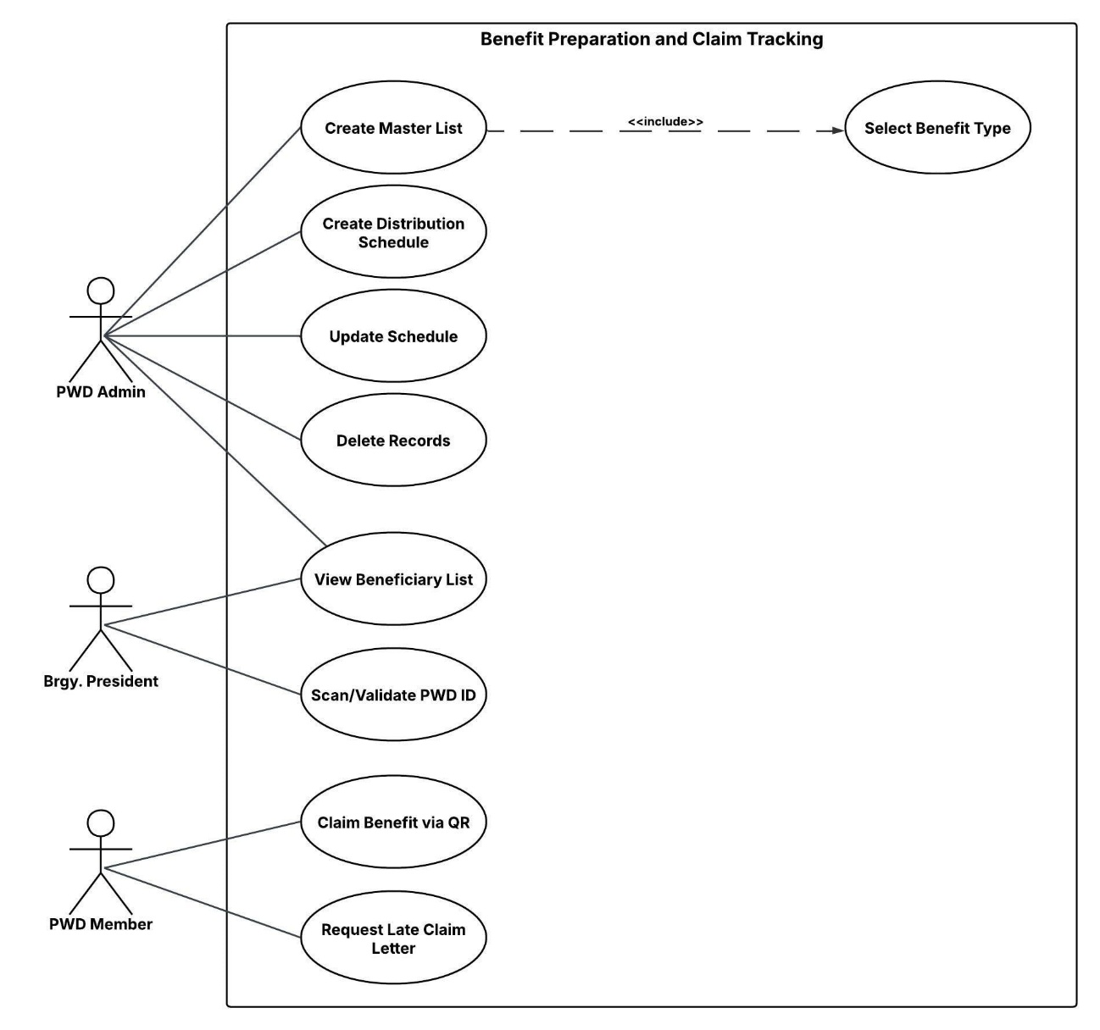**Figure 5. Use Case Diagram for Benefits Preparation and Tracking Claims Subsystem**

This use case diagram outlines the process for a "Benefit Preparation and Claim Tracking" system, defining the roles and interactions of three key actors: the PWD Admin, the Brgy. President, and the PWD Member. The PWD Admin is responsible for the core administrative tasks, including creating a Master List of beneficiaries, which is a multi-step process that includes selecting a benefit type, filtering the beneficiaries, and generating a payroll list. The admin also can create and update a distribution Schedule and Delete Records. The Brgy. The Brgy. President has a local-level role, with the ability to view the Beneficiary List and Scan/validate PWD IDs to confirm the identity of claimants. Finally, the PWD Member, or beneficiary, can Claim Benefit via QR and, if necessary, Request a Late Claim Letter. This diagram provides a clear and organized view of the entire benefit distribution process, from the initial administrative setup to the final claiming of benefits by the PWD members.

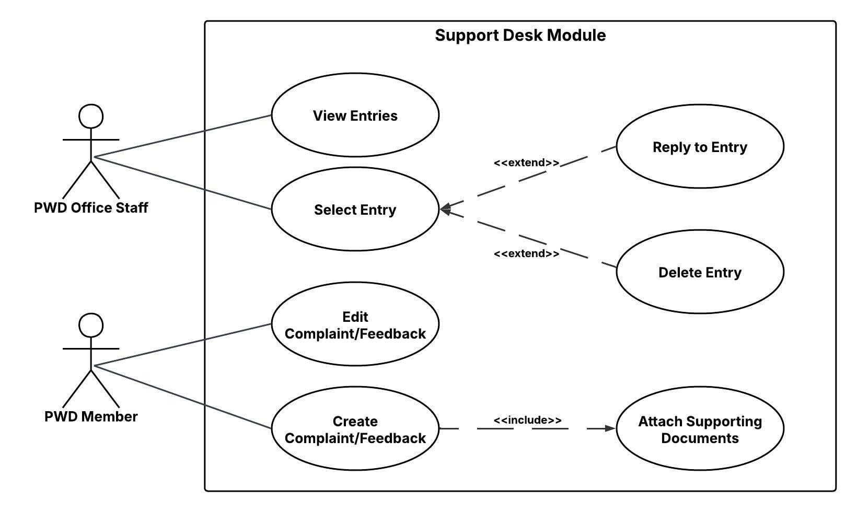**Figure 6. Use Case Diagram for Support Desk Subsystem**

This use case diagram outlines the process for a "Support Desk Module," detailing the interactions between a PWD Member and PWD Office Staff. The PWD Member can create a Complaint/Feedback, a process that obligates them to Attach Supporting Documents. The member can also edit the Complaint/Feedback they have already submitted. The PWD Office Staff manages these submissions, with the ability to View Entries and Select entries. Once an entry is selected, the staff has the option to either Reply to Entry or Delete Entry. This diagram provides a clear, logical flow for the entire support desk process, from the submission of feedback by a PWD member to its management and resolution by office staff.

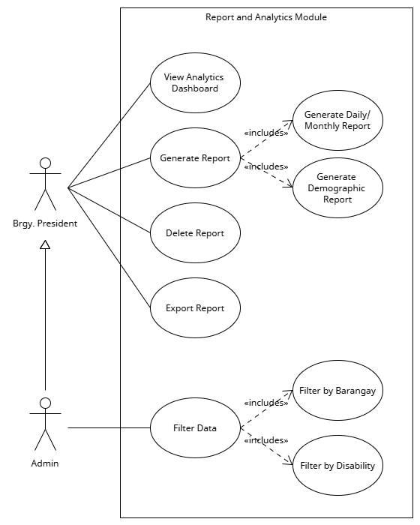**Figure 7. Use Case Diagram for Report and Analytics Subsystem**

This diagram illustrates the functionalities of a "Report and Analytics Module" and the two main users, or actors, who interact with it: the "Brgy. President" and the "Admin." The diagram shows that the Brgy. President is the primary user, with access to several key functions. These include the ability to View Analytics Dashboard, which provides a visual summary of data, and to Generate Report, which is a core function that allows for the creation of reports. The generation of reports is further specified to include two specific types: Generate Daily/Monthly Report and Generate Demographic Report. The Brgy. President can also delete Report and Export Report, enabling them to manage and share the generated reports. The diagram also identifies an "Admin" actor, who is shown to inherit the roles of the Brgy. President, indicated by the generalization arrow. The Admin has a specific and separate capability: to Filter Data. This action includes the more granular functions of Filter by Barangay and Filter by Disability, suggesting the Admin has a more privileged role in data manipulation and management. Overall, the diagram clearly delineates the different roles and responsibilities of the system users and the specific actions they can perform within the module.

**Figure 8. Use Case Diagram for Accessibility Subsystem**

This diagram outlines the process for an "Accessibility Module" and the interactions of a PWD Member with the system's accessibility features. The PWD Member can view Accessibility Settings to see their current preferences. They can also Update Preferences, a process that automatically includes the step to Save Preferences. Lastly, the user has the option to Reset to Default at any time. This simple yet critical use case diagram clearly shows how a PWD member can easily manage their accessibility settings to improve their experience with the system.

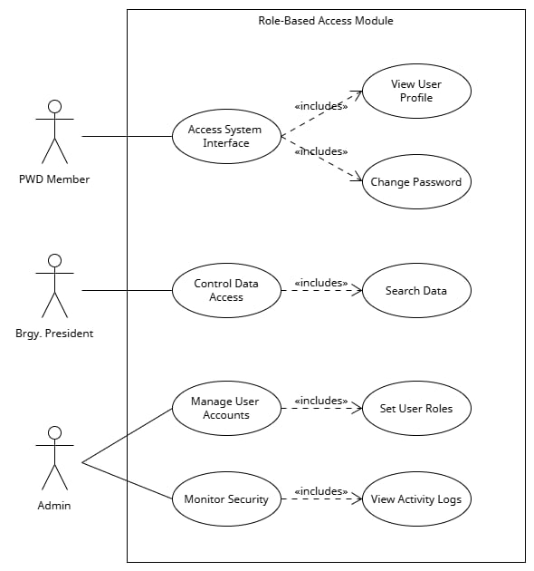**Figure 9. Use Case Diagram for Role-Based Access Subsystem**

This diagram outlines the process for a "Role-Based Access Module," which details the different levels of access and control for users within the system. It presents a clear hierarchy of permissions for three distinct roles: PWD Member, Brgy. President, and PWD Admin. A PWD Member has the most basic access, allowing them to Access System Interface, which includes the abilities to View User Profile and Change Password. The Brgy. President has a higher level of authority, enabling them to Control Data Access, a function that includes the ability to Search Data. At the top of the hierarchy is the PWD Admin, who has the highest level of control. The PWD Admin can Generate Reports, Manage User Accounts (which includes setting user roles), and Monitor Security (which includes viewing activity logs). The diagram's use of generalization arrows shows that a PWD Admin inherits the capabilities of the Brgy. President, who in turn inherits the capabilities of the PWD Member, effectively illustrating a multi-tiered system where each user has the appropriate level of access to perform their designated tasks.

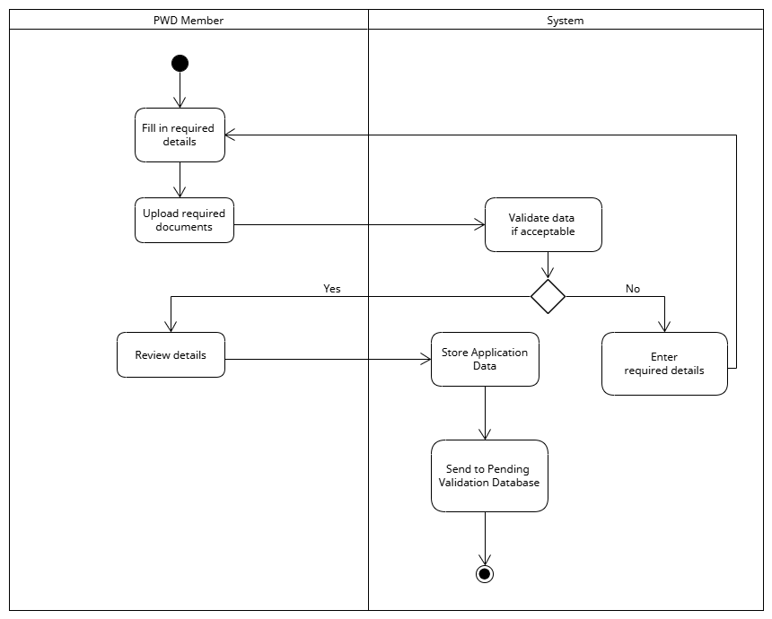 **Figure 10. Activity Diagram for Registering PWD Member**

This activity diagram illustrates the comprehensive process a Person With Disability (PWD) member follows when registering through the system. The journey begins with the member filling in all the required personal details and uploading all necessary supporting documents for verification. The system then automatically performs an initial data validation to ensure the provided information meets all specified criteria. Should the validation fail, the user is prompted to go back and correct the information, creating a loop until the data is deemed acceptable. Once the validation is successful, the member is given the opportunity to review all the submitted details one final time before the application data is securely stored within the system's database. Finally, the completed application is sent to a pending validation database, signaling that it is ready for a more detailed administrative review by staff and completing the user's part of the registration process.

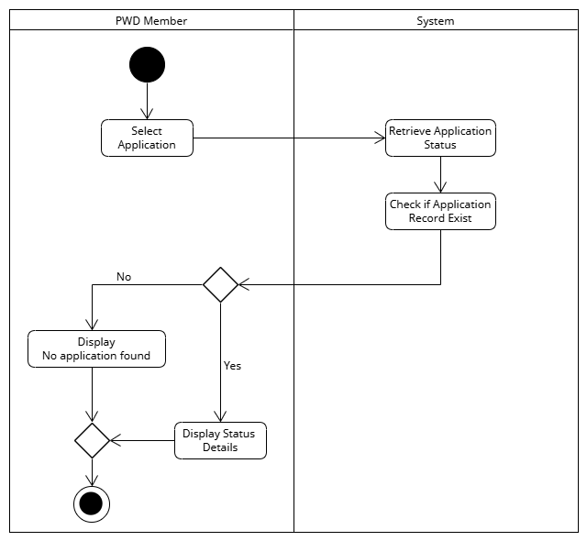**Figure 11. Activity Diagram for Viewing PWD Application Status**

This activity diagram illustrates the process a Person With Disability (PWD) member follows to check the status of a submitted application. The process begins with the member selecting the specific application they wish to view. The system then takes over, retrieving the application status and performing a critical check to see if an application record exists. If a record is not found, the system displays a No application found message to the member. However, if the record does exist, the system proceeds to display the detailed status of the application, which could be under review, approved, or rejected. This process is crucial for providing timely updates to applicants, ensuring transparency and a smooth user experience. It effectively concludes the interaction by giving the member the information they need. By streamlining this step, the system helps reduce the need for manual inquiries and provides a more efficient service.

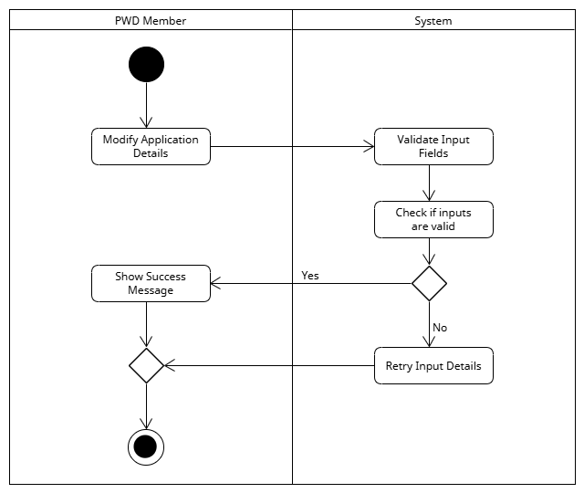**Figure 12. Activity Diagram for Editing PWD Application**

This activity diagram illustrates the process a Person With Disability (PWD) member follows to modify details within an existing application. The process initiates when the PWD member chooses to Modify Application Details. Upon this action, the system immediately takes over to Validate Input Fields, checking the integrity and format of the changes made. Following this, the system proceeds to "Check if inputs are valid." If the inputs are found to be invalid No, the system prompts the member to Retry Input Details, looping back to allow corrections. Conversely, if the inputs are valid Yes, the system proceeds to Show Success Message, confirming that the application details have been successfully updated. This concludes the process of editing the PWD application, ensuring data accuracy and providing immediate feedback to the user.

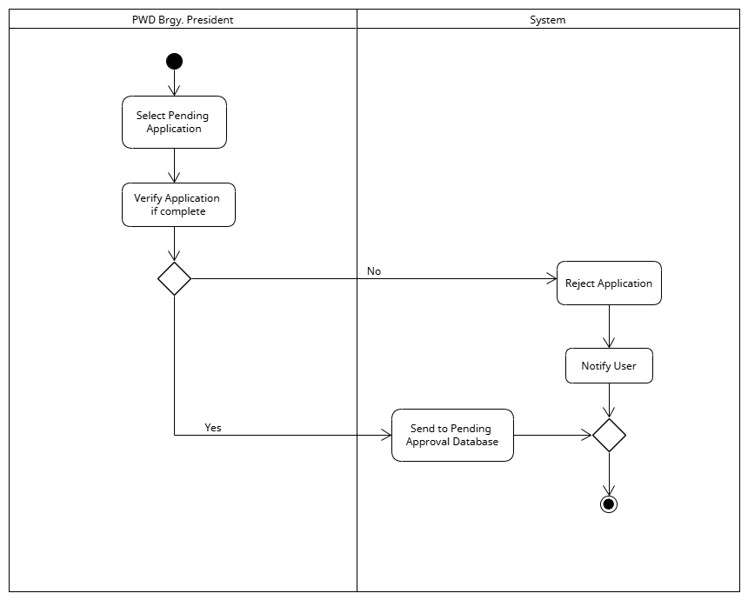**Figure 13. Activity Diagram for Validate PWD Application**

This activity diagram shows the workflow for a PWD Brgy. The President is responsible for validating a PWD application within the system. It is divided into two swim lanes: one for the PWD Brgy. President and one for the System. The process begins with the PWD Brgy. President selects a Pending Application. They then validate the application if it is complete. A decision point, represented by a diamond, checks if the validation is successful. If the validation is No, the system will Reject Application and then Notify User before the process ends. If the validation is Yes, the system will send to the Pending Approval Database, completing the process. The diagram clearly illustrates the steps for a PWD Brgy. President to successfully validate an application, including the decision-making and notification processes.

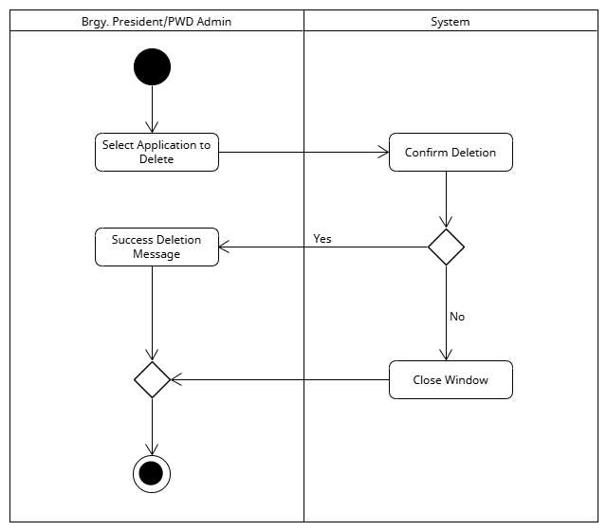**Figure 14. Activity Diagram for Deleting Application**

This activity diagram illustrates the administrative process for a Barangay President or PWD Admin to delete a PWD application. The process begins with the administrator selecting a specific application to delete, which prompts the system to request a final confirmation. This crucial step is in place to prevent accidental data loss. If the administrator confirms the deletion, a "Success Deletion Message" is displayed, and the process concludes. Conversely, if the administrator chooses not to confirm, the process ends by simply closing the window without making any permanent changes to the application record. This workflow is designed to ensure that a necessary verification step is included, providing a layer of security before any application is permanently removed from the system's database.

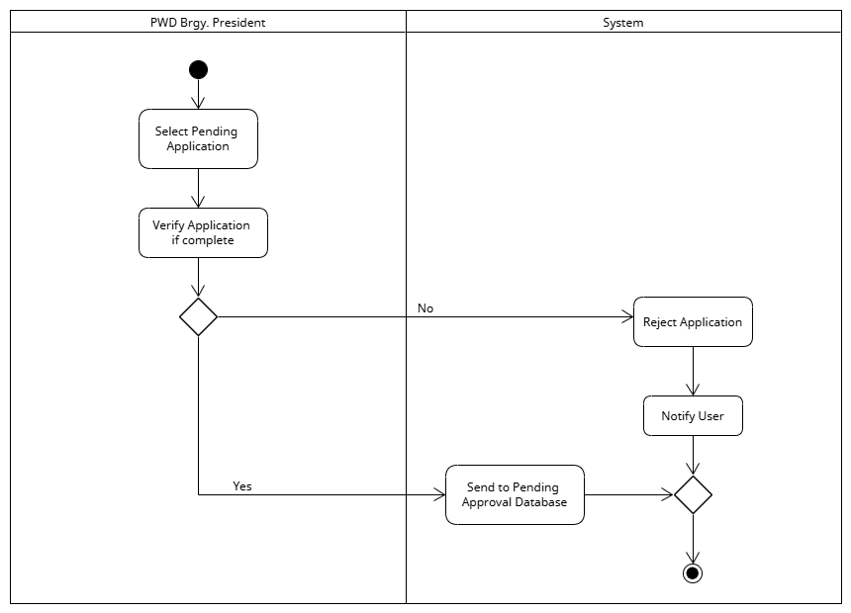**Figure 15. Activity Diagram for Approving PWD Application**

This activity diagram illustrates the process a PWD Barangay President follows to approve or reject a pending PWD application. The process starts when the administrator selects a pending application from the system. They then verify if the application is complete. If it is not complete, the administrator chooses to reject the application, and the system automatically notifies the user of this decision. If the application is complete, it is sent to a Pending Approval Database for final processing. This workflow ensures that all applications are thoroughly reviewed before a final decision is made, guaranteeing accuracy and completeness. By automating user notifications for rejected applications, the system provides a timely feedback loop. Ultimately, this process streamlines the administrative review and approval of all submitted applications.

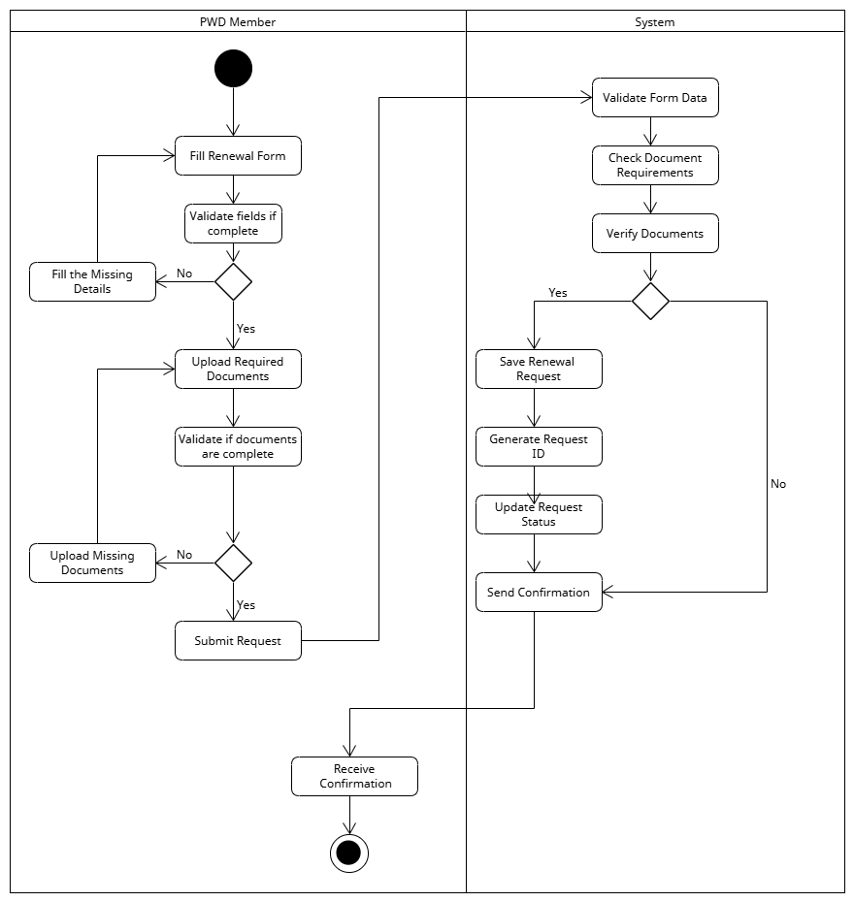**Figure 16. Activity Diagram for Creating PWD ID Renewal Request**

This activity diagram illustrates the comprehensive process a PWD member follows to submit a request for an ID renewal. The member begins by filling out a renewal form. The system validates the fields, and if any are incomplete, the member is prompted to fill in the missing details. Once the form is complete, the member uploads the required documents. The system validates these documents, and if any are missing, the member is asked to upload them. After everything is complete, the member submits the request. The system then validates all data and documents, saves the renewal request, generates a unique Request ID, and updates the request status. Finally, the system sends a confirmation to the user, who then receives a confirmation message, concluding the 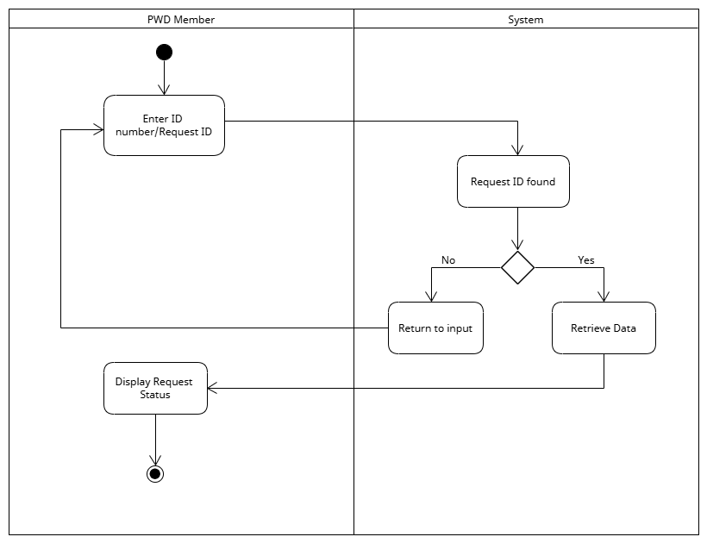process.

**Figure 17. Activity Diagram for Viewing Request Status**

This activity diagram illustrates how a PWD member can check the status of a request they have submitted. The process begins with the member entering an ID number or Request ID into the system. The system then checks its database to see if a matching ID is found. If the ID is not found, the user is prompted to return to the input screen to re-enter the correct ID. If the ID is found, the system retrieves the corresponding data and displays the request's current status. This concludes the process, providing the member with a clear and efficient way to track the progress of their submission. This self-service feature is crucial for reducing administrative workload and enhancing transparency for the user.

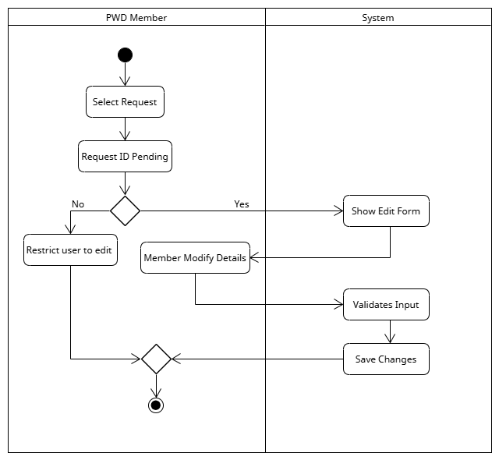**Figure 18. Activity Diagram for Editing Pending Request**

This activity diagram outlines the workflow for a PWD Member to edit a pending request. The diagram is divided into two swimlanes, representing the "PWD Member" and the "System." The process begins with the member selecting a request. A decision is then made to check if the request ID is pending. If it is not pending ("No"), the system restricts the user from editing, and the process ends. If the request ID is pending ("Yes"), the system shows an edit form to the member, who can then edit the details. The system then validates the new input before saving the changes. This diagram ensures that members can only edit their requests while they are in a pending state, thereby maintaining data integrity and control over the application process.

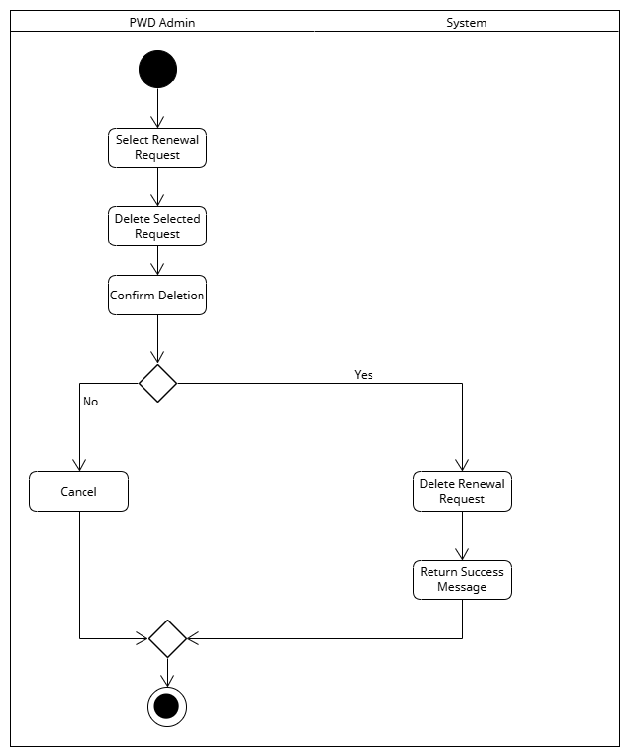**Figure 19. Activity Diagram for Deleting a PWD Renewal Request**

This activity diagram illustrates the process a PWD Admin follows to delete a submitted renewal request. The admin begins by selecting the specific request and then chooses to delete it, prompting the system for a confirmation. If the admin chooses not to confirm the action, the process is canceled. However, if the deletion is confirmed, the system proceeds to delete the renewal request and returns a success message to the admin, concluding the process. This critical two-step process of selection and confirmation prevents accidental deletions and ensures data integrity. It provides a secure method for administrators to manage renewal requests. The streamlined workflow is essential for maintaining accurate records and keeping the system 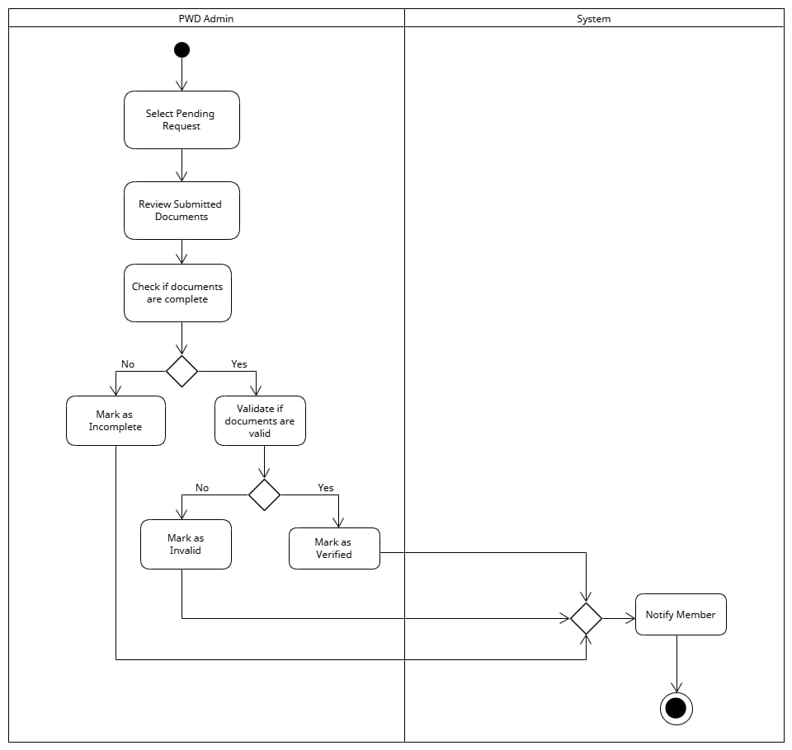-organized.

**Figure 20. Activity Diagram for PWD Request Verification Process**

This activity diagram shows the process for a PWD Admin to review and act on a pending request. The admin starts by selecting a pending request. They then review the submitted documents and check if they are complete. If the documents are not complete, the admin marks the request as incomplete. If the documents are complete, the admin validates their authenticity. If they are not valid, the admin marks them as invalid. If they are valid, the admin marks them as verified. The system then notifies the PWD member of the status change, concluding the process. This workflow provides a critical layer of quality control, ensuring that all submissions are accurate and legitimate before moving forward. By categorizing requests as incomplete, invalid, or verified, the system helps streamline administrative tasks and provides clear communication to the applicant. The automated notification at the end of the process ensures timely updates, which is vital for a positive user experience.

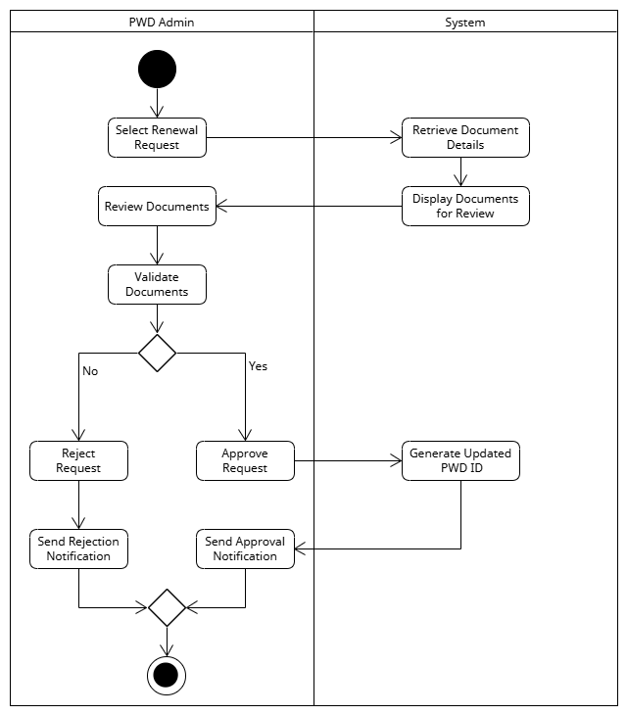**Figure 21. Activity Diagram for PWD ID Renewal Approval**

This activity diagram illustrates the comprehensive process a PWD Admin follows to handle a renewal request. The process begins with the admin selecting a renewal request, which prompts the system to retrieve and display the relevant documents for review. The admin then reviews and validates these documents. If the documents are not valid, the admin rejects the request and the system sends a rejection notification to the user. Conversely, if the documents are valid, the admin approves the request. Upon approval, the system generates an updated PWD ID and sends an approval notification to the user. This workflow ensures all renewal requests are properly verified before a new ID is issued. This systematic approach enhances efficiency and reduces manual errors by automating key steps. Ultimately, it provides a transparent and reliable way to manage the renewal of PWD identification, benefiting both administrators and applicants.

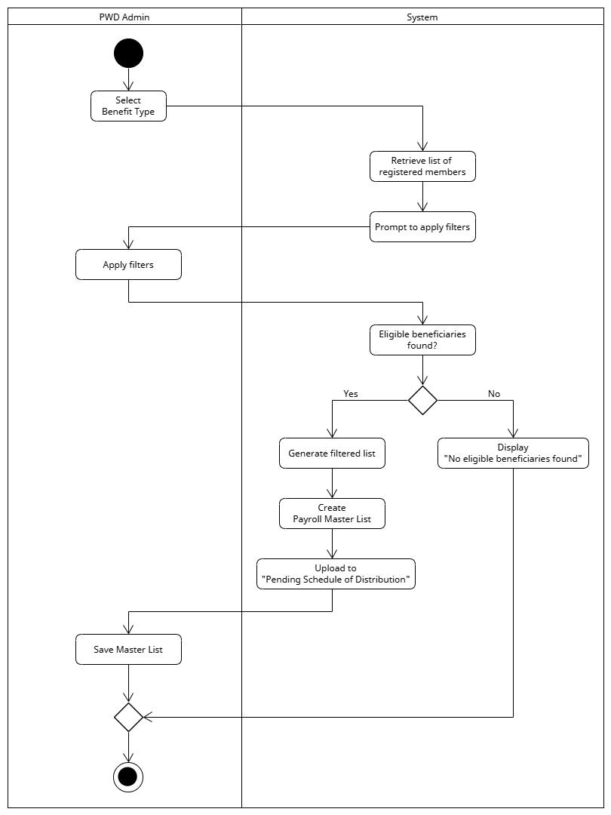**Figure 22. Activity Diagram for Creating Masterlist**

This activity diagram illustrates the comprehensive process by which a PWD Admin, in collaboration with the system, generates a refined payroll master list for benefit distribution. The workflow is initiated when the admin selects a specific benefit type, prompting the system to retrieve a complete list of all registered members. The admin then applies various filters, effectively narrowing the large dataset to a more manageable and relevant group, after which the system performs a crucial check to confirm that eligible beneficiaries were found. Upon a successful discovery, the system proceeds to automatically generate a filtered list, create a final payroll master list from this data, and upload it to the designated "Pending Schedule of Distribution" before the admin performs the final action of saving the document.

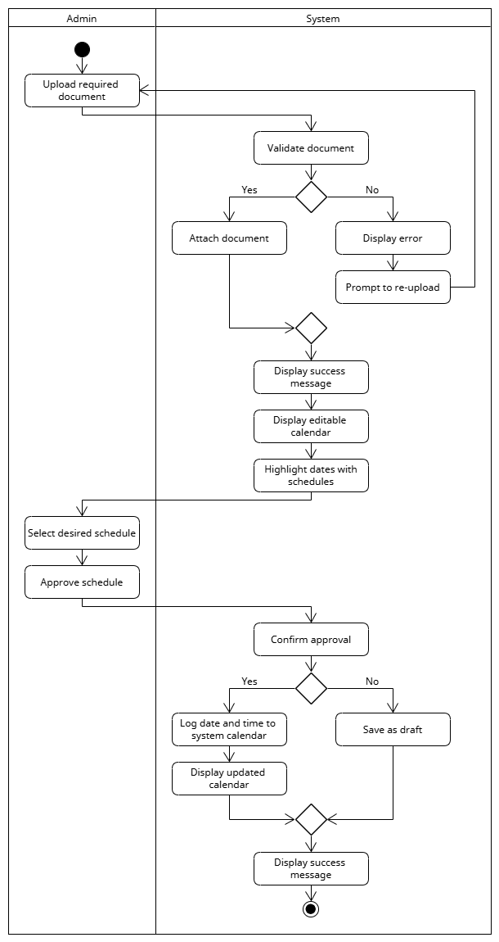

**Figure 23. Activity Diagram of Creating Distribution Schedule**

This activity diagram outlines the process an Admin follows to create a distribution schedule. The process begins with the Admin uploading a required document. The system then validates the document. If the validation is successful, the system attaches the document, displays a success message, and shows an editable calendar with highlighted dates. If the validation fails, the system displays an error and prompts the Admin to re-upload. After a successful upload, the Admin selects the desired schedule and approves it. The system then prompts for confirmation of approval. If confirmed, the system logs the date and time to the system calendar and displays the updated calendar. If not confirmed, the schedule is saved as a draft. Finally, the system displays a success message to the Admin, completing the process. This comprehensive workflow ensures schedules are created with proper document validation and a clear approval process. The ability to save a schedule as a draft provides flexibility for planning without a final commitment. The document validation step acts as a crucial safeguard, ensuring only correct and usable files are attached to the schedule.

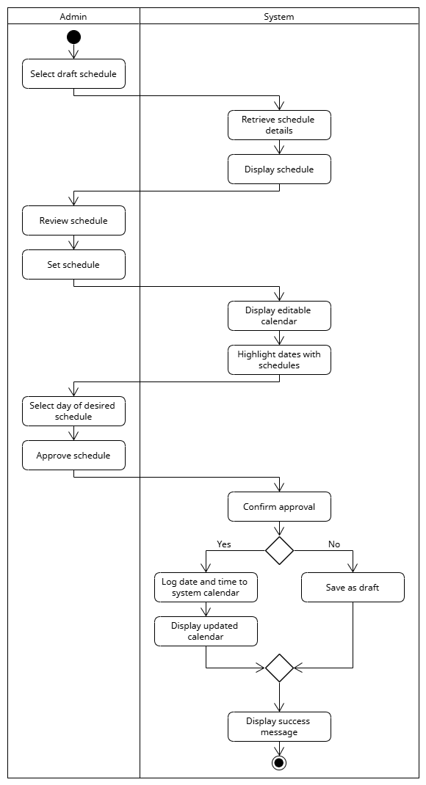

**Figure 24. Activity Diagram for Updating Schedule**

This activity diagram outlines the process an Admin follows to update a schedule. The process begins when the Admin selects a draft schedule, which the system then retrieves and displays. The Admin reviews and sets the schedule, and the system presents an editable calendar with highlighted dates. The Admin then selects a day and approves the schedule. The system prompts the Admin to confirm the approval. If the Admin confirms, the system logs the date and time to the system calendar and displays the updated calendar. If the Admin does not confirm, the schedule is simply saved as a draft. Finally, the system displays a success message to the Admin, completing the process. This structured workflow ensures schedules are updated with a clear approval and logging process. This multi-step approach prevents accidental scheduling and guarantees accuracy. The ability to save as a draft offers flexibility for administrators to plan without immediate commitment. The final success message provides clear feedback that the task has been completed.

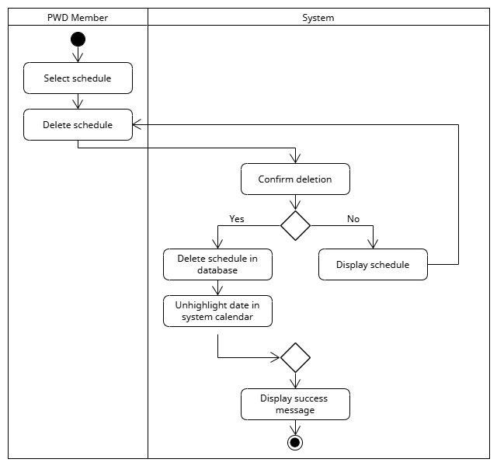**Figure 25. Activity Diagram for Deleting a Schedule**

This activity diagram outlines the process a PWD Member follows to delete a schedule. The process begins when the PWD Member selects a schedule and chooses to delete it. The system then prompts the user to confirm the deletion. If the PWD Member confirms the action, the system deletes the schedule in the database and unhighlights the corresponding date in the system calendar. If the PWD Member does not confirm, the process is terminated, and the system displays the schedule again. After a successful deletion, the system displays a success message to the user, completing the process. This structured approach ensures that a schedule is deleted with proper confirmation and a clear indication of success. The confirmation step serves as a vital safeguard against accidental deletions. This methodical workflow prevents unintended data loss and ensures that all changes are intentional. The success message provides clear feedback to the user that the task has been completed.

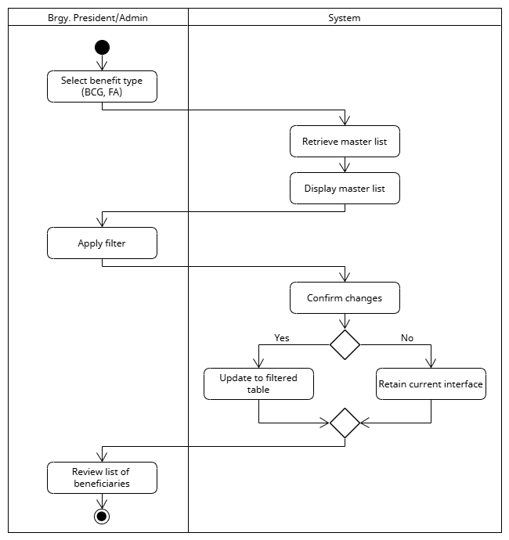**Figure 26. Activity Diagram for Viewing Beneficiary List `**

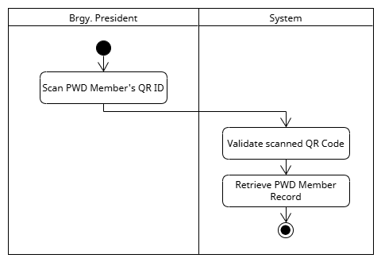This activity diagram outlines the process a Brgy. President or Admin follows to view a list of beneficiaries. The process begins with the user selecting a benefit type, such as BCG or FA. The system then retrieves and displays the master list of all beneficiaries. To refine the list, the user can then apply a filter. The system prompts the user to confirm the filter changes. If the user confirms, the system updates the interface to show the filtered table. If the user does not confirm, the system retains the current interface with the full master list. Finally, the user reviews the filtered list of beneficiaries, completing the process. This structured workflow ensures that the administrator can efficiently and accurately access and review specific beneficiary information. The filter and confirmation steps work together as a key part of the process, ensuring the user gets the most relevant data. The ability to quickly narrow down a large list to a specific subset of beneficiaries significantly improves efficiency. The entire workflow ensures that data access is both quick and precise, which is crucial for making informed decisions.

**Figure 27. Activity Diagram for Scanning a PWD QR ID**

This activity diagram illustrates the process a Brgy. President follows to scan and validate a PWD member's ID. The process begins when the president scans the QR code on the member's ID. The system then automatically validates the scanned QR code to ensure it is authentic and readable. After successful validation, the system retrieves the corresponding PWD member's record from the database. The process concludes once the record has been retrieved, providing the president with the necessary information for a transaction. This streamlined and automated process significantly reduces manual data entry and potential errors. It provides a quick and reliable method for verifying a member's identity. This functionality is crucial for efficient and secure delivery of services to PWD members.

**Figure 28. Activity Diagram for Claiming a Benefit via QR Code** 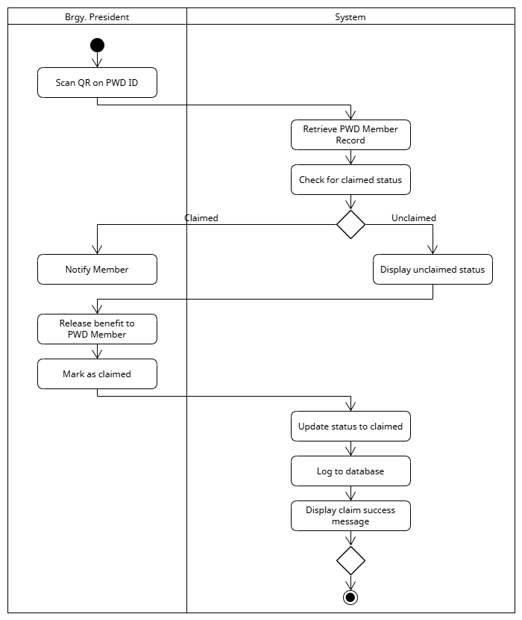

This activity diagram outlines the process a Brgy. President follows to facilitate a benefit claim using a QR code. The process begins when the Brgy. President scans the QR code on the PWD ID. The system then retrieves the PWD Member Record and checks the claimed status. A crucial decision point is whether the benefit has already been claimed. If it has, the system notifies the PWD Member. If the benefit is unclaimed, the system displays the unclaimed status. The Brgy. President then releases the benefit to the PWD Member and marks it as claimed. The system then updates the status to claimed in the database, logs the claim, and displays a success message. This streamlined workflow ensures that benefit claims are verified, properly documented, and 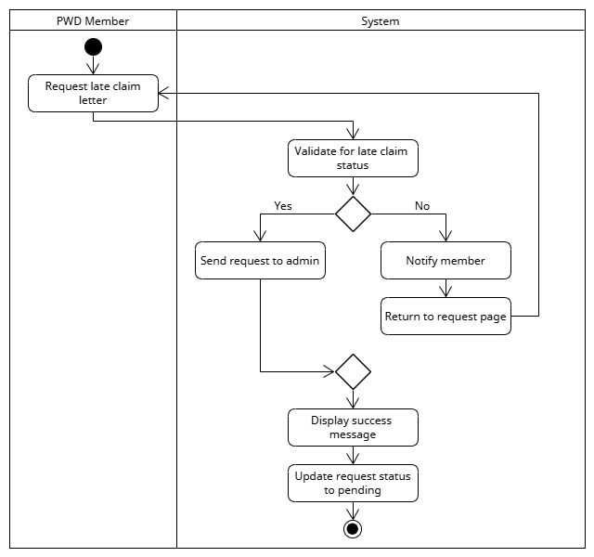updated in real-time.

**Figure 29. Activity Diagram for Requesting Late Claim**

This activity diagram outlines the process a PWD Member follows to request a late claim. The process begins with the PWD Member requesting a late claim letter. The system then validates for late claim status. If the validation is successful, the system sends the request to the Admin, displays a success message, and updates the request status to pending. If the validation is not successful, the system notifies the member and returns to the request page, allowing them to try again. This systematic approach ensures that late claim requests are properly validated and logged for review. The validation step is a critical safeguard to ensure only eligible requests are processed. This structured workflow provides a clear and efficient pathway for members to address missed claim opportunities.

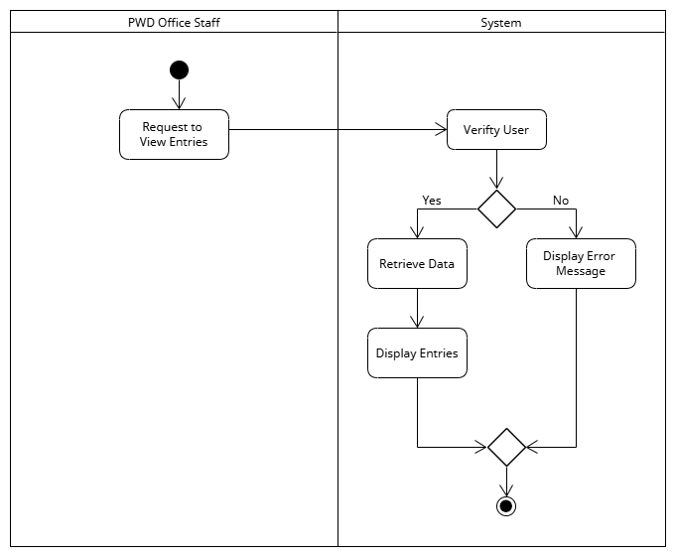

**Figure 30. Activity Diagram for Viewing Entries**

This diagram illustrates the process a PWD Brgy. President follows to approve or reject a pending application. The process begins with the president selecting a pending application and verifying if it is complete. If the application is incomplete, it is rejected, and the system automatically notifies the user of the decision. If the application is complete, it is sent to a pending approval database for further processing, which concludes this stage of the workflow. This process is crucial for ensuring that all applications are thoroughly reviewed for completeness before moving forward. By providing a clear pathway for either rejection or approval, the system helps to maintain data accuracy and streamline administrative tasks. The automated notification feature also ensures that applicants receive timely feedback, improving overall user satisfaction.

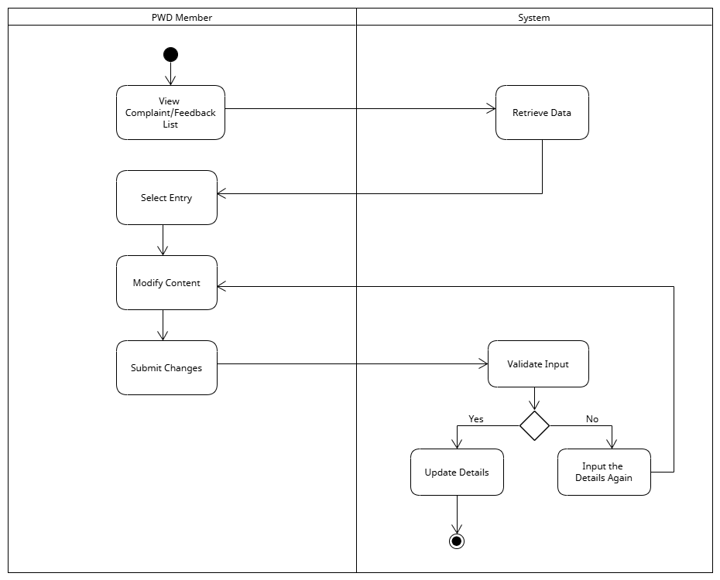**Figure 31. Activity Diagram for Editing a Complaint or Feedback**

This activity diagram illustrates the process for a PWD member to modify a previously submitted complaint or feedback entry. The member begins by viewing their list of complaints or feedback and selecting a specific entry. They can then modify its content and submit the changes. The system immediately validates the new input. If the input is not valid, the member is prompted to correct the details. If the input is valid, the system updates the information, and the process concludes. This workflow provides users with essential control over their feedback, ensuring they can correct any errors or add new information after the initial submission. The built-in validation step helps maintain data integrity, and the automated process streamlines the task for the user, removing the need for administrative intervention. This functionality is crucial for promoting transparency and a responsive feedback system.

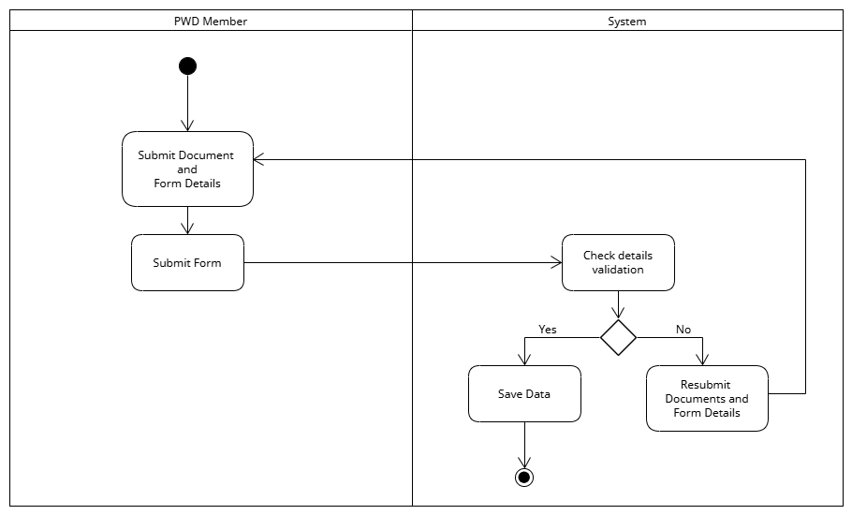**Figure 32. Activity Diagram for Creating a Complaint or Feedback**

This activity diagram illustrates the process a PWD member follows to submit a new complaint or feedback entry. The member begins by submitting both the required documents and form details. The system then automatically checks the details for validation. If the validation is unsuccessful, the member is prompted to resubmit the documents and form details, creating a loop until the information is acceptable. If the validation is successful, the system saves the data, and the process concludes. This workflow ensures that all submissions are complete and accurate before being finalized in the system. The automated validation process significantly reduces manual administrative checks. It also provides an efficient and user-friendly way for members to voice their concerns. This systematic approach promotes data integrity and a more responsive feedback mechanism.

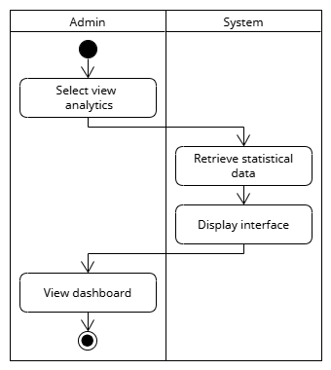 **Figure 33. Activity Diagram for Viewing Analytics Dashboard**

This activity diagram outlines the process an Admin follows to view the system’s analytics dashboard. The process begins when the Admin selects the option to view analytics. The system then retrieves the statistical data and displays the interface. The Admin can then view the dashboard and the process concludes. This simple and straightforward workflow ensures that the Admin can quickly and efficiently access key data for analysis. This direct approach eliminates unnecessary steps, providing a fast and seamless user experience. The ability to instantly retrieve and display the data is crucial for real-time monitoring. Ultimately, this process supports data-driven decision-making by making important metrics readily available.

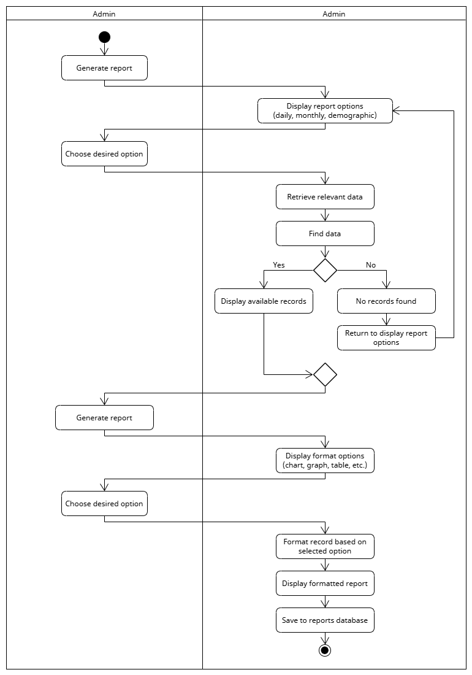

**Figure 34. Activity Diagram for Generating Report**

This activity diagram outlines the comprehensive process an Admin follows to generate a report. The process begins when the Admin chooses to generate a report, and the system displays available report options (daily, monthly, demographic). After the Admin selects their desired option, the system retrieves the relevant data and attempts to find records. If records are found, the system displays them; if not, it indicates that no records were found and returns to the report options. The Admin then chooses a desired format option (chart, graph, table, etc.). The system then formats the data, displays the formatted report, and saves it to the reports database. This structured workflow ensures reports are created with precision and saved for future use. The system's ability to handle various report types and formatting options gives the Admin great flexibility. This multi-step process guarantees the generated reports are both accurate and tailored to specific needs.

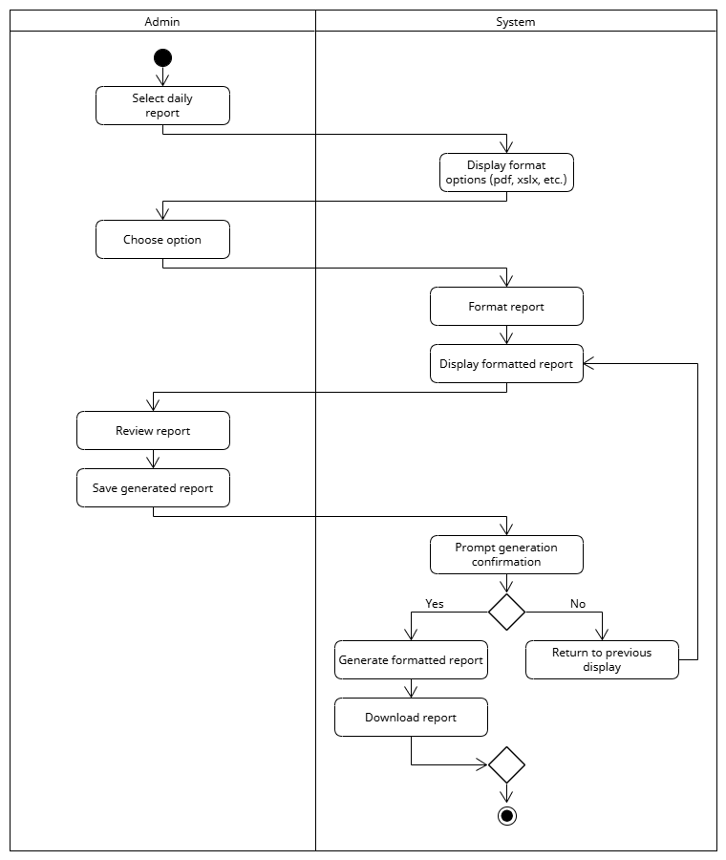 **Figure 35. Act Diagram for Exporting a Daily Report**

This activity diagram outlines the process an Admin follows to export a daily report. The process begins when the Admin selects to export a daily report. The system then displays the format options (pdf, xlsx, etc.), and the Admin chooses their desired format. The system then formats the report and displays the formatted version for the Admin to review. After reviewing, the Admin chooses to save the generated report. The system then prompts for confirmation of the report generation. If the Admin confirms, the system generates the formatted report and allows the Admin to download the report. If the Admin chooses not to confirm, the system returns to the previous display, allowing the Admin to make changes. This multi-step workflow ensures reports are saved in the correct format with a clear confirmation and download process.

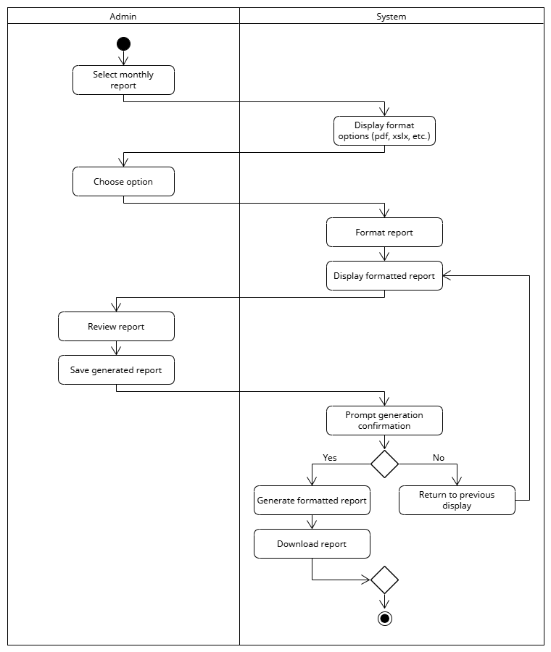 **Figure 36. Activity Diagram for Exporting Monthly Report**

This activity diagram outlines the process an Admin follows to export a monthly report. The process begins when the Admin selects to export a monthly report. The system then displays the format options (pdf, xlsx, etc.), and the Admin chooses their desired format. The system then formats the report and displays the formatted version for the Admin to review. After reviewing, the Admin chooses to save the generated report. The system then prompts for confirmation of the report generation. If the Admin confirms, the system generates the formatted report and allows the Admin to download the report. If the Admin chooses not to confirm, the system returns to the previous display, allowing the Admin to make changes. This multi-step workflow ensures reports are saved in the correct format with a clear confirmation and download process.

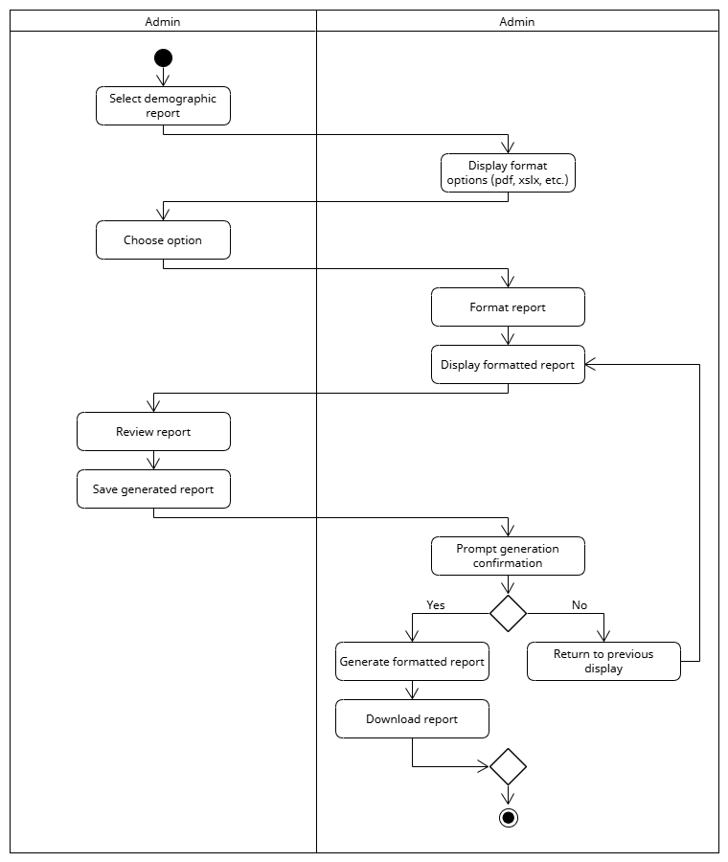 **Figure 37. Activity Diagram for Exporting Demographic Report**

This activity diagram outlines the process an Admin follows to export a demographic report. The process begins when the Admin selects to export a demographic report. The system then displays the format options (pdf, xlsx, etc.), and the Admin chooses their desired format. The system then formats the report and displays the formatted version for the Admin to review. After reviewing, the Admin chooses to save the generated report. The system then prompts for confirmation of the report generation. If the Admin confirms, the system generates the formatted report and allows the Admin to download the report. If the Admin chooses not to confirm, the system returns to the previous display, allowing the Admin to make changes. This multi-step workflow ensures reports are saved in the correct format with a clear confirmation and 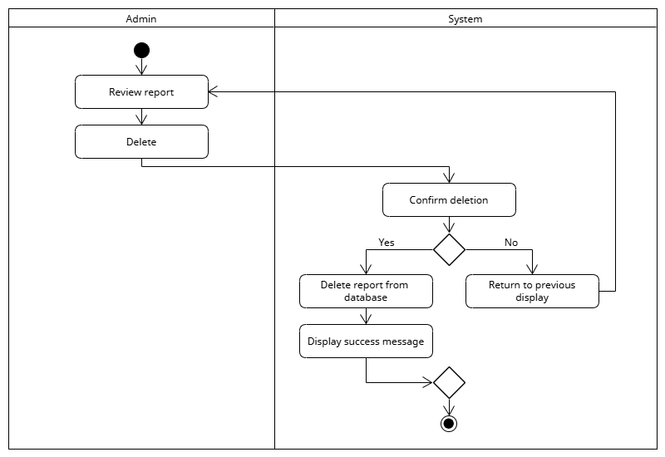download process.

**Figure 38. Activity Diagram for Deleting Report**

This activity diagram outlines the process an Admin follows to delete a report. The process begins when the Admin reviews a report and then chooses to delete it. The system then prompts the Admin to confirm the deletion. If the Admin confirms, the system deletes the report from the database and displays a success message. If the Admin chooses not to confirm, the system returns to the previous display without deleting the report. This structured workflow ensures that report deletions are intentional and confirmed before being permanently removed from the database. The confirmation step is a crucial safeguard against accidental data loss. A clear confirmation process is key to maintaining the integrity of the system's records.

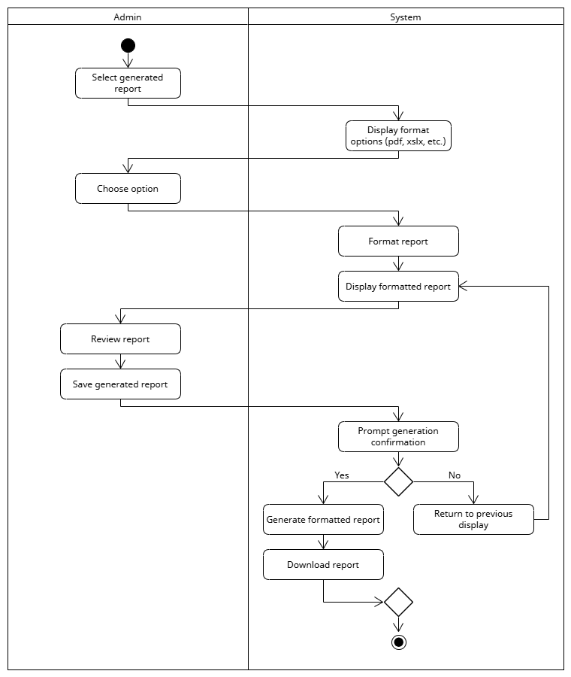 **Figure 39. Activity Diagram for Exporting Report**

This activity diagram outlines the process an Admin follows to export a generated report. The process begins with the Admin selecting a report they want to export. The system then displays the format options (pdf, xlsx, etc.), and the Admin chooses their desired format. The system then formats the report and displays the formatted version for the Admin to review. After reviewing, the Admin chooses to save the generated report. The system then prompts for confirmation of the report generation. If the Admin confirms, the system generates the formatted report and allows the Admin to download the report. If the Admin chooses not to confirm, the system returns to the previous display, allowing the Admin to make changes. This multi-step workflow ensures reports are saved in the correct format with a clear confirmation and download process.

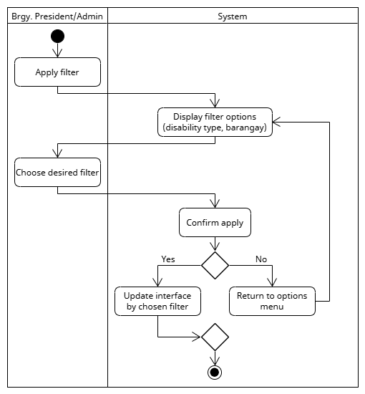**Figure 40. Activity Diagram for Applying Filter**

This activity diagram outlines the process of a Brgy. President or Admin follows to apply a filter to reports and analytics. The process begins with the user selecting to apply a filter. The system then displays the filter options (disability type, barangay), and the user chooses their desired filter. The system then prompts for confirmation to apply the filter. If the user confirms, the system updates the interface with the chosen filter. If the user chooses not to confirm, the system returns to the options menu without applying the filter. This structured workflow ensures that all filter applications are intentional and result in the correct data display.

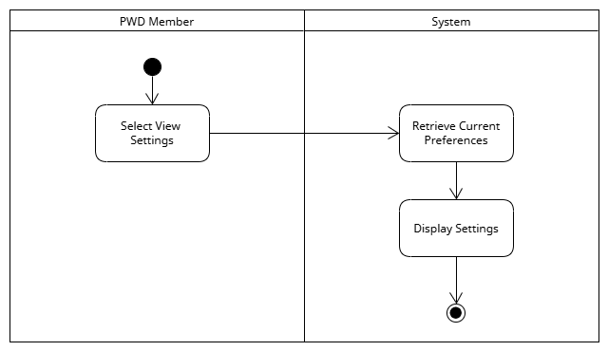

**Figure 41. Activity Diagram for** **Viewing Accessibility Settings**

This diagram illustrates the process a PWD member follows to view their accessibility settings. The process begins when the member selects the option to view their settings. The system then responds by retrieving the user's current preferences from the database. Once the preferences are retrieved, the system displays the settings for the member to review. The process concludes after the settings are shown, providing the PWD member with a quick and easy way to check their current configurations. This streamlined workflow enhances user autonomy by allowing them to independently verify their chosen accessibility options. It also reduces the need for administrative support, making the system more efficient. Ultimately, this ensures the system is tailored to individual needs, promoting a better user experience for all members.

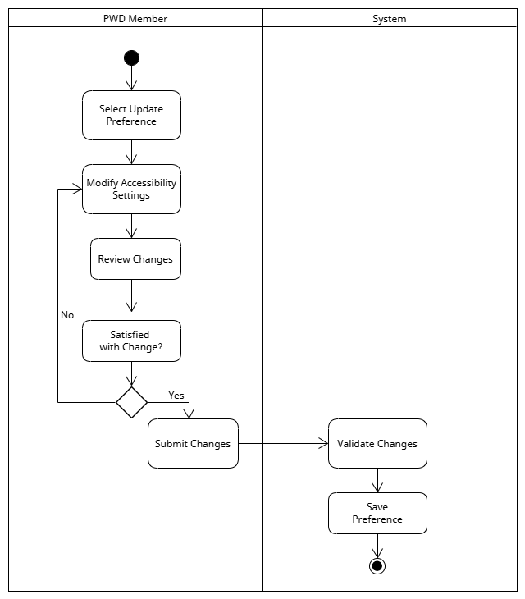**Figure 42. Activity Diagram for Updating Accessibility Preferences**

This activity diagram illustrates the process for a PWD Member to update their accessibility preferences within a system. The process begins with the member selecting to update preferences and then modifying the settings. The member reviews the changes and reaches a key decision point: if they are not satisfied, the process loops back, allowing them to modify the settings again; if they are satisfied, they submit the changes. The system then takes control to validate and save the new preferences, concluding the workflow. The diagram uses two swimlanes to clearly separate the actions of the "PWD Member" and the "System" and uses standard UML symbols to show the entire workflow 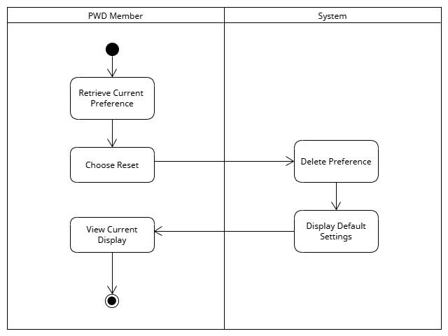from start to finish.

**Figure 43. Activity Diagram for Resetting Preferences to Default**

This activity diagram illustrates the process for a PWD Member to reset their preferences to the system's default settings. The process begins with the member retrieving their current preferences. They then choose to reset, which prompts the system to delete the existing preferences. The system then displays the default settings to the user. The member can then view the current display, and the process concludes. The diagram uses two swimlanes to clearly separate the actions of the "PWD Member" and the "System" and uses standard UML symbols, such as rounded rectangles for actions and black circles for the start and end of the process, to depict the entire workflow.

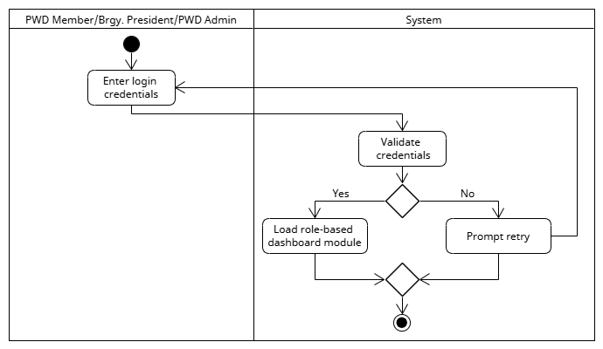**Figure 44. Activity Diagram for Accessing the System Interface**

This activity diagram illustrates the process for any user to log into the system. The process begins when a PWD Member, Brgy. President, or PWD Admin enters their login credentials. The system then validates these credentials. If the validation is successful, the system loads the appropriate role-based dashboard module, which provides access tailored to the user's specific role. If the credentials are not valid, the system prompts the user to retry, allowing them to correct their login details before the process concludes. This streamlined authentication ensures that only authorized personnel can access the system's features. It also provides a clear and intuitive pathway for users to begin their tasks. The system's ability to automatically load the correct dashboard for each user role enhances security and improves overall navigation.

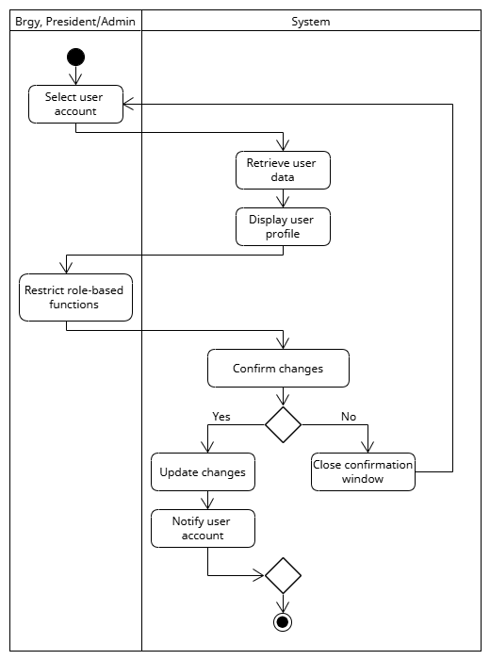**Figure 45. Activity Diagram for Controlling Data Access**

This activity diagram illustrates the process by which a Brgy. President or Admin manages user data and controls access to the system. The process begins when the Brgy. President or Admin selects a specific user account. The system then retrieves and displays the corresponding user data. The Brgy. President or Admin can then restrict role-based functions for that user. After making the necessary changes, the user is prompted to confirm the changes. If the changes are confirmed, the system updates the changes and notifies the user account. If the changes are not confirmed, the system closes the confirmation window, and the process ends. The system's ability to easily manage user accounts and control access to specific functions enhances security and ensures that only authorized personnel have access to the system.

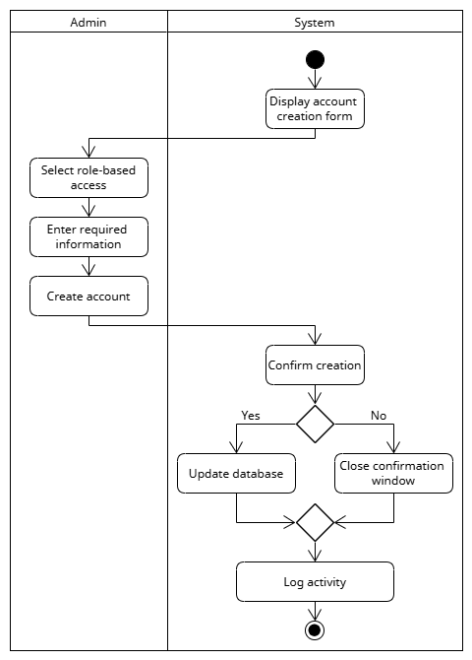**Figure 46. Activity Diagram for Creating User Account**

This activity diagram outlines the process an Admin follows to create a new user account. The process begins with the system displaying the account creation form to the Admin. The Admin then selects the role-based access for the new user, ensuring they are assigned the correct permissions. Next, the Admin enters the required information before initiating the account creation. The system then prompts the Admin to confirm the creation. If the Admin confirms, the system updates the database with the new user's information. If not, the process ends by closing the confirmation window. Finally, the system logs the activity to maintain an auditable record of the new account creation before the process concludes. This systematic approach ensures that new accounts are created with proper authorization and documentation.

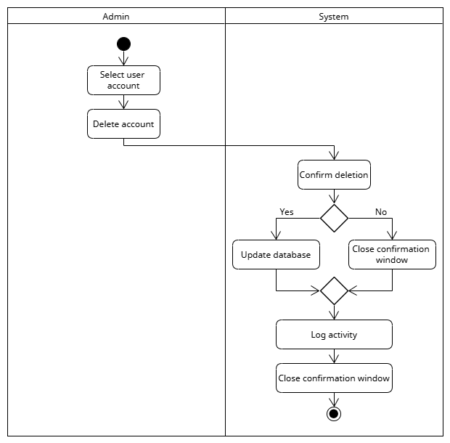**Figure 47. Activity Diagram for Deleting User Account**

This activity diagram outlines the process an Admin follows to delete a user account. The process starts when the Admin selects a specific user account and chooses to delete it. The system then prompts the Admin to confirm the deletion. If the Admin confirms the action, the system updates the database to remove the user's data. If the Admin does not confirm, the process ends, and the system closes the confirmation window. After a successful deletion, the system logs the activity to maintain a record of the action before the process concludes. This workflow ensures that all account deletions are intentional and properly documented. The system's confirmation step is a critical safeguard against accidental data loss. This comprehensive process ensures that the deletion of a user account is both secure and auditable. The final logging of the activity is essential for administrative oversight and security purposes.

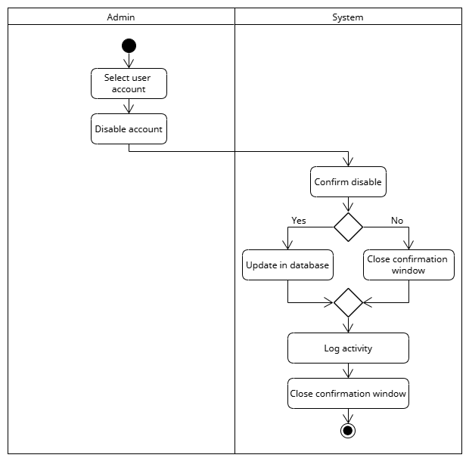**Figure 48. Activity Diagram for Disabling User Account**

This activity diagram outlines the process an Admin follows to disable a user account. The process begins when the Admin selects a user and chooses to disable their account. The system then prompts the Admin to confirm the disablement. If the Admin confirms, the system updates the database to revoke the user's access. If the Admin chooses not to confirm, the process is terminated, and the system closes the confirmation window. After a successful disablement, the system logs the activity to maintain a record of the action before the process concludes. This systematic approach ensures that user accounts are disabled with proper authorization and a clear audit trail.

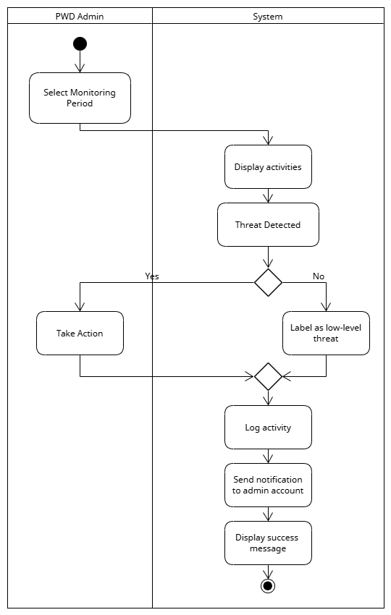**Figure 49. Activity Diagram for Monitoring Security**

This activity diagram outlines the process for a PWD Admin to monitor security threats within the system. The admin begins by selecting a specific monitoring period, and the system responds by displaying the relevant activities. The system then automatically checks if a threat is detected. If a threat is found, the admin is prompted to take immediate action. If no threat is detected, the system labels the activity as a low-level threat, logs it, sends a notification to the admin's account, and displays a success message to confirm the process is complete. This workflow ensures continuous monitoring and a clear protocol for responding to potential security risks. The automated logging and notification system provides a robust and proactive security measure, enabling the admin to stay informed even during low-level incidents. This proactive approach is crucial for maintaining the integrity and safety of the entire system.

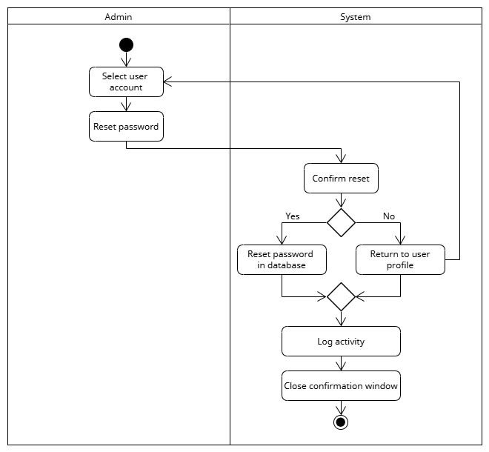**Figure 50. Activity Diagram for Resetting a User Password**

This activity diagram outlines the process an Admin follows to reset a user's password. The process begins when the Admin selects a user account and chooses to reset the password. The system then prompts the Admin to confirm the password reset. If the Admin confirms the action, the system proceeds to reset the password in the database. If the Admin chooses not to confirm, the process is terminated, and the system returns to the user profile. After a successful password reset, the system logs the activity to maintain a record before the process concludes. This systematic approach ensures that password resets are authorized and properly documented. The confirmation step serves as a critical security measure to prevent accidental password changes. This clear workflow helps maintain the integrity of user accounts. Logging the activity provides an essential audit trail for administrators.

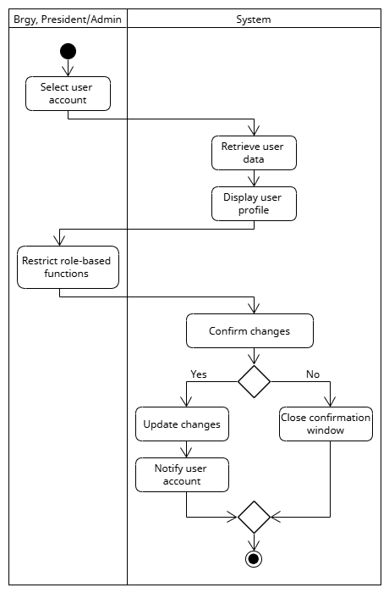 **Figure 51. Activity Diagram for Restricting a User Data Access**

This activity diagram outlines the process a Brgy. President or Admin follows to restrict a user’s data access. The process begins when the Brgy. President or Admin selects a user account. The system then retrieves and displays the user’s profile, allowing the administrator to review their current permissions. The administrator can then restrict specific role-based functions. The system prompts the administrator to confirm the changes. If confirmed, the system updates the changes in the database and notifies the user account of the new restrictions. If the changes are not confirmed, the system closes the confirmation window and the process concludes without any changes. This structured workflow ensures that all permission changes are intentional and properly implemented.

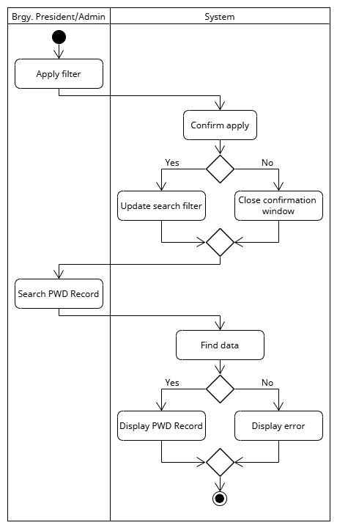 **Figure 52.** **Activity Diagram for Searching Data**

This activity diagram outlines the process a Brgy. President or Admin follows to search for PWD records within the system. The process begins with the user applying a filter to refine their search. The system then prompts the user to confirm the filter application. If confirmed, the system updates the search filter to narrow the search results. If the user does not confirm, the process ends without a filter being applied. After the filter is updated (or if no filter was applied), the user searches for a PWD record. The system then attempts to find the data. If the data is found, the system displays the PWD record; otherwise, it displays an error to the user. This streamlined process ensures an efficient and accurate way to locate specific records. The confirmation step for the filter helps prevent accidental searches and improves accuracy. This structured workflow provides a clear and intuitive way for administrators to retrieve necessary information.

**Figure 53.** **Activity Diagram for Setting User’s Role**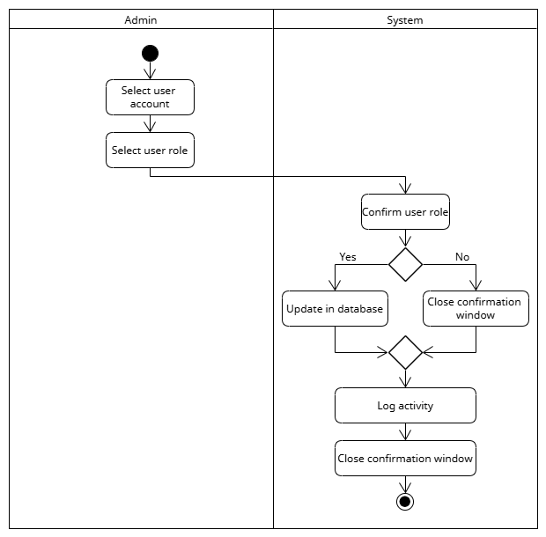s

This activity diagram outlines the process an Admin follows to set or change a user's role. The process begins when the Admin selects a specific user account and then selects the desired user role. The system then prompts the Admin to confirm the user role change. If the Admin confirms, the system updates the database to reflect the new role. If the Admin chooses not to confirm, the process ends, and the system closes the confirmation window. After a successful update, the system logs the activity to maintain a record of the change before the process concludes. This systematic approach ensures that user roles are assigned with proper authorization and an auditable trail. The confirmation step serves as a critical safeguard against accidental assignment errors. This structured workflow helps to maintain the integrity of access permissions across the system. Furthermore, logging the activity provides an essential audit trail for security and administrative oversight.

**Figure 54.** **Activity Diagram for Updating User Account** 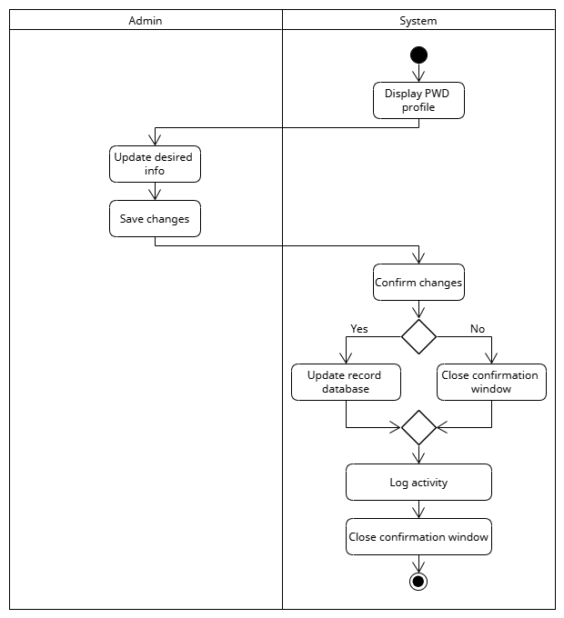

This activity diagram outlines the process an Admin follows to update a user's account information. The process begins when the system displays the PWD profile. The Admin then updates the desired information and chooses to save the changes. The system then prompts the Admin to confirm the changes. If the Admin confirms, the system updates the record database with the new information. If the Admin chooses not to confirm, the process is terminated, and the system closes the confirmation window. After a successful update, the system logs the activity to maintain a record of the changes before the process concludes. This systematic approach ensures that user account updates are properly authorized and auditable. The confirmation step serves as a vital safeguard against unintended or incorrect data entry. The clear and logical progression of this workflow minimizes errors and ensures data integrity. Lastly, the final logging step provides a comprehensive audit trail for all changes made to a user's record.

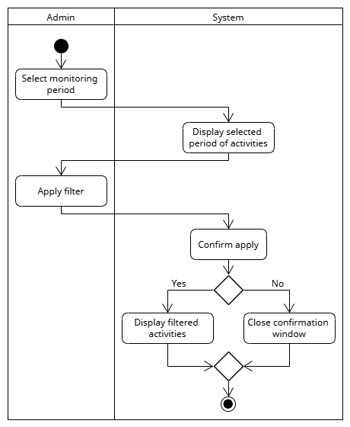**Figure 55.** **Activity Diagram for Viewing Activity Log**

This activity diagram outlines the process an Admin follows to view the system's activity log. The process begins with the Admin selecting a monitoring period to define the timeframe of activities they want to view. The system then displays the activities for that selected period. The Admin can then apply a filter to narrow down the displayed activities. The system prompts the Admin to confirm the filter application. If the Admin confirms, the system displays the filtered activities. If the Admin chooses not to confirm, the process is terminated, and the system closes the confirmation window. This streamlined approach allows the Admin to efficiently and accurately review the system's activity log. The ability to filter the log helps the Admin focus on specific events, making it easier to monitor for security or audit purposes. This methodical process ensures all log reviews are thorough and targeted. The confirmation step provides a critical 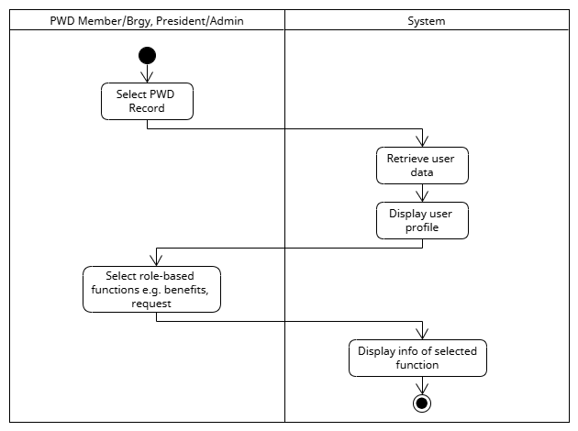safeguard against unintended filter applications.

**Figure 56. Activity Diagram for Viewing Activity Log**

This activity diagram outlines the process for a PWD Member, Brgy. President, or Admin to view a record within the system. The process begins when the user selects a specific PWD record. The system then retrieves the user data and displays the user profile. The user can then select from various role-based functions, such as viewing benefits or making a request. The system then displays the information related to the selected function, providing the user with the specific details they need before the process concludes. This streamlined approach ensures that users can easily and efficiently access relevant information based on their needs and permissions. The ability to access specific functions after viewing a profile helps to streamline administrative tasks. This process ensures that users can quickly navigate to the exact information they require. The final display of information ensures that the user's specific request is met, completing the workflow.

**Figure 57. Class Diagram for PWD Management System**

This UML Class Diagram serves as a detailed blueprint for a PWD (Persons With Disabilities) management system, built upon a core User superclass from which Admin, BarangayPresident, and PWDMember classes inherit their base attributes and behaviors. Each of these roles has specific responsibilities: the Admin manages system-level functions like approving applications and generating reports; the BarangayPresident handles community-specific tasks such as validating documents and posting announcements; and the PWDMember is the primary user who can submit applications and complaints, and view and claim benefits. The diagram also illustrates how these roles interact with various associated classes: Applications are submitted by PWDMembers and processed by Admins; Announcements are managed by the BarangayPresident; and AuditLog records actions for all user types. A central part of the system is the process for managing benefits, where a BenefitClaim class acts as a link between a PWDMember and a specific Benefit, effectively tracking the claim status and managing a many-to-many relationship between these two entities.

# Ethical Considerations

To ensure the privacy, confidentiality, and well-being of all participants. The researchers and study will follow strict ethical guidelines. Participation will be voluntary; participants will receive an informed consent form before involvement. Personal and sensitive information will be kept private and anonymous if requested to protect the participant's identity. Additionally, the study will be conducted following the Non-Disclosure Agreement (NDA), and the proposed system will comply with the Data Privacy Act of 2012 to ensure that the patient and clinic data are used only for the purpose of the study.

Participants will also have the right to withdraw from the study without facing any negative consequences. Throughout the study, the participants will be treated with respect, following the sensitivity and importance of maternity care. All interviews, focus group discussions, and surveys will be conducted to ensure participants feel comfortable, heard, and valued. The researchers are committed to upholding the highest ethical standards to provide its participants with a safe and trustworthy environment.

# Literature Cited

[1] P. Promjung and T. Seetawan, "Disability Information System/Software (DIS)," Int. J. Mod. Phys. Conf. Ser., vol. 12, no. 1, p. 119, 2021. [Online]. Available: https://www.mdpi.com/2227-7390/12/1/119

[2] M. Nkurayija, "National Council of Persons with Disabilities (NCPD) - Rwanda," Int. Disabil. Alliance, 2022. [Online]. Available: https://www.internationaldisabilityalliance.org/sites/default/files/marcel-nkurayija-ncpd-rwanda-30-march.pdf

[3] J. Weber et al., "The Lost Link: Localization of the UN Convention on the Rights of Persons with Disabilities," CBM, Germany, 2022. [Online]. Available: https://www.cbm.org/fileadmin/resourcespace/Localization_of_the_UN_CRPD_AT.pdf

[4] CBM Global, "Disability Data Advocacy Toolkit 2022," 2023. [Online]. Available: https://cbm-global.org/resource/disability-data-advocacy-toolkit

[5] B. Carpenter et al., "The disability statistics questionnaire review database (DS-QR Database): a database of population censuses and household surveys with internationally comparable disability questions," Int. J. Popul. Data Sci., 2024.

[6] S. Ruggles et al., "Integrated Public Use Microdata Series, International: Version 7.5 [dataset]," IPUMS, Minneapolis, MN, 2024. [Online]. Available: https://doi.org/10.18128/D020.V7.5

[7] M. Walsh, R. Cormack, and M. MacLachlan, "Digital and Assistive Technology use in Disability Services during Covid-19: A Report on the Experiences of 120 service providers," Natl. Clin. Program People Disabil., 2020. [Online]. Available: https://www.hse.ie/eng/about/who/cspd/ncps/disability/programme-publications/digital-and-assistive-technology-use-in-disability-services-during-covid19-report.pdf

[8] R. McHale, C. Ffrench, and B. McGuire, "The experiences and views of adults with intellectual disabilities accessing digital mental health interventions: a qualitative systematic review and thematic synthesis," J. Appl. Res. Intellect. Disabil., vol. 36, no. 3, pp. 448–457, 2023.

[9] M. Zonneveld, A. H. Patomella, E. Asaba, and S. Guidetti, "The use of information and communication technology in healthcare to improve participation in everyday life: a scoping review," Disabil. Rehabil., 2020.

[10] S. Baek, S. Lee, and S. Y. Lee, "Association of ICT utilization level and life satisfaction of people with disabilities: Focus on differences in disability type," Asian Soc. Work Policy Rev., vol. 16, no. 2, pp. 165–174, 2022. [Online]. Available: https://doi.org/10.1111/aswp.12256

[11] Asia Foundation, "Philippines Disability Sector Research: An Initial Analysis of Access to Social and Public Services," Asia Found., 2024. [Online]. Available: https://asiafoundation.org/wp-content/uploads/2024/08/Philippines-Disability-Sector-Research-An-Initial-Analysis-of-Access-to-Social-and-Public-Services.pdf

[12] C. Toquero, "Inclusion of People with Disabilities amid COVID-19: Laws, Interventions, Recommendations," ResearchGate, 2020. [Online]. Available: https://www.researchgate.net/publication/342459170_Inclusion_of_People_with_Disabilities_amid_COVID-19_Laws_Interventions_Recommendations

[13] I. A.-I. Longoria, R. Bustamante-Bello, M. S. Ramírez-Montoya, and A. Molina, "Systematic mapping of digital gap and gender, age, ethnicity, or disability," Sustainability, vol. 14, no. 3, p. 1297, 2022.

[14] S. Johansson, J. Gulliksen, and C. Gustavsson, "Disability digital divide: the use of the internet, smartphones, computers and tablets among people with disabilities in Sweden," Univers. Access Inf. Soc., vol. 20, no. 1, pp. 105–120, 2021.

[15] E. G. Alampay, E. Cureg, and D. J. Quebral, "Enabling the Disabled: Assessment of local mechanisms for programs and services for persons with disabilities (PWDs) 2024- focus on Persons with Disabilities Affairs Office (PDAO)," ResearchGate, 2024. [Online]. Available: https://www.researchgate.net/publication/337026594_PROJECT_FINAL_REPORT_PROJECT_Assessment_of_Local_Mechanisms_for_Programs_and_Services_for_PWDs_-Focus_on_Persons_with_Disabilities_Affairs_Office

[16]“Person with Disability Information System Database Design,” iNetTutor.com, Oct. 26, 2020. https://www.inettutor.com/source-code/person-with-disability-information-system-database-design/ (accessed Mar. 23, 2025).

[17]H. Padilla, “Senior Citizen Pwd Record Management System,” Scribd, 2025. https://www.scribd.com/document/793724792/Senior-Citizen-Pwd-Record-Management-System

[18]“Authentication challenge pages,” Psa.gov.ph, 2025. https://psa.gov.ph/sites/default/files/ncs-manuscripts-powerpoint/8.3.3%2520Making%2520the%2520Invisible%2520Visible%2521%2520The%2520Significance%2520of%2520an%2520Integrated%2520Data%2520Management%2520System%2520for%2520Persons%2520with%2520Disabilities.pdf (accessed Mar. 23, 2025).

[19]C. G. Author, “Barangay Senior Citizen And PWD Information System - Capstone Guide,” Capstone Guide, Jan. 20, 2025. https://capstoneguide.com/barangay-senior-citizen-and-pwd-information-system/ (accessed Mar. 23, 2025).

[20]“Person with Disability (PWD) Information System ER Diagram,” iNetTutor.com, Dec. 04, 2020. https://www.inettutor.com/diagrams/person-with-disability-pwd-information-system-er-diagram/ (accessed Mar. 23, 2025).

[21]N. Regidor, M. D. Cabrera, Queenelyn Salibio, A. S. Bugarin, J. C. Mateo, and A. M. Gallardo, “Enhancing Service Efficiency and Accessibility for Persons with Disabilities: An Information Management System with SMS Notification in Libertad, Antique,” Journal of innovative technology convergence., vol. 6, no. 3, pp. 67–74, Sep. 2024, doi: https://doi.org/10.69478/jitc2024v6n3a07.

[22]“Person with Disability Information System Free Template in PHP and Bootstrap,” iNetTutor.com, Nov. 15, 2020. https://www.inettutor.com/source-code/person-with-disability-information-system-free-template-in-php-and-bootstrap/ (accessed Mar. 23, 2025).

[23] D. M. Kadijevich, D. Masliković, and B. M. Tomić, “Dataset regarding access to information for persons with disabilities in Serbia,” Data in Brief, vol. 32, p. 106309, Sep. 2020, doi: https://doi.org/10.1016/j.dib.2020.106309.

[24] S. Kaindaneh, J. de Kadt, S. Bechange, E. Jolley, N. Smart, and E. Schmidt, “An assessment of the Education Management Information System in Sierra Leone and potential for enhanced disability inclusiveness,” International Journal of Educational Research Open, vol. 7, p. 100399, Nov. 2024, doi: https:/doi.org/10.1016/j.ijedro.2024.100399.

[25] E. Rocher, E. Andreu-Cabedo, and F. Galán-Peris, “The role of machine learning in future autonomous network and service management,” in Proc. IEEE 5G World Forum, 2020, pp. 67–72. Available: https://ieeexplore.ieee.org/document/9117340.

[26] C. M. John and M. P. Joseph, "Comparison between Retrieval Time of Manual and Electronic Medical Records - A Case Study," ResearchGate, Aug. 2022. Available: https://www.researchgate.net/publication/362526741.

[27] R. Kurniawan et al., “Analysis and Design of Information Systems for Health Data Recording,” J. Phys.: Conf. Ser., vol. 1860, no. 1, p. 012001, 2021. Available: https://iopscience.iop.org/article/10.1088/1742-6596/1860/1/012001/meta.

[28] C. Vincent et al., "MediCord: A Web-Based Health Record Management System," ResearchGate, Oct. 2022. Available: https://www.researchgate.net/publication/364324883.

[29] F. O. Oni et al., "Web-Based Students' Record Management System for Tertiary Institutions," ResearchGate, Apr. 2020. Available: https://www.researchgate.net/publication/340952903.

[30] J. Gonzales et al., "Development of a Browser-Based Cooperative Records Management with Loan Assessment System," Eastern Visayas State University, 2023. Available: https://www.evsu.edu.ph/university-research-and-created-works/development-of-a-browser-based-cooperative-records-management-with-loan-assessment-system/.

[31] A. Chatterjee et al., “Privacy-Preserving Authentication for Secure Record Access,” IEEE Internet Things J., 2020. Available: https://ieeexplore.ieee.org/abstract/document/9072779.

[32] S. K. Tan et al., "Clinic Management System: An Implementation Study," J. Health Technol. Developments, vol. 7, no. 4, pp. 45–50, Dec. 2023. Available: https://journal.hmjournals.com/index.php/JHTD/article/view/1125.

[33] M. C. Perez, Web-Based Patient Record Management System, Cavite State University, Capstone Project, 2021. Available: https://www.studocu.com/ph/document/cavite-state-university/capstone-project/web-based-patient-record-management-system/47668591.

[34] S. M. Wabwire et al., "Development of a Cloud-Based Record Management System," Busitema University Institutional Repository, 2023. Available: https://ir.busitema.ac.ug/handle/20.500.12283/3916.

[35] R. Kumar, "An Enhanced Blockchain-Based Record System," in Proc. IEEE Blockchain Conf., 2022. Available: https://ieeexplore.ieee.org/document/9794525.

[37] K. N. Sharma et al., "Design and Implementation of a Web-Based Records Management Solution," IEEE Int. Conf. Softw. Eng. Appl., 2023. Available: https://ieeexplore.ieee.org/document/9835988.

[38] T. Surya and M. Wijaya, “Web-Based Database Implementation,” J. Informatika, vol. 5, no. 1, pp. 35–42, 2024. Available: https://jutif.if.unsoed.ac.id/index.php/jurnal/article/view/145.

[39] M. Holbrook et al., “Patient Record Systems and Digital Tools,” JMIR Formative Res., vol. 5, no. 11, Nov. 2021. Available: https://formative.jmir.org/2021/11/e23789/.

[40] D. K. Singh et al., “Secure Patient Record Transfer Using AI,” in Proc. IEEE Healthcare Data Conf., 2024. Available: https://ieeexplore.ieee.org/document/10882381.

[41] R. Reyes et al., Web-Based Resident Record Management System, Scribd, 2022. Available: https://www.scribd.com/document/573576647.

[42] J. Caballero, Student Records Management System, Scribd, 2021. Available: https://www.scribd.com/document/547836220.

[43] P. Hernandez, Clinic Record Management System, Scribd, 2023. Available: https://www.scribd.com/document/575273192/Clinic-record-management-system.

[44]J. Joseph, "Web-Based Record Tools in Healthcare," Int. J. Comput. Appl., vol. 32, no. 5, pp. 123–128, 2020. Available: https://www.scribd.com/document/511029535/joseph-2020-ijca-919908.

[45] C. Bindoy, Bindoy Local Civil Registrar Record Management System, Scribd, 2023. Available: https://www.scribd.com/document/418980990.

[46] ISO (2016). Information and Documentation – Records Management – Part 1: Concepts and Principles (ISO 15489-1:2016). International Organization for Standardization. https://www.iso.org/standard/62542.html

[47] Brennen, S., & Kreiss, D. (2016). Digitalization. In The International Encyclopedia of Communication Theory and Philosophy. Wiley. https://doi.org/10.1002/9781118766804.wbiect111

[48] Stallings, W. (2017). Network Security Essentials: Applications and Standards (6th ed.). Pearson. https://www.pearson.com/store/p/network-security-essentials-applications-and-standards/P100002657625

[49] Ferraiolo, D., Kuhn, D. R., & Chandramouli, R. (2003). Role-Based Access Control. Artech House. https://csrc.nist.gov/projects/role-based-access-control

[50] Parasuraman, R., & Riley, V. (1997). Humans and Automation: Use, Misuse, Disuse, Abuse. Human Factors, 39(2), 230–253. https://doi.org/10.1518/001872097778543886

[51] Republic of the Philippines, Republic Act No. 7277: Magna Carta for Disabled Persons, Mar. 24, 1992. [Online]. Available: https://www.officialgazette.gov.ph/1992/03/24/republic-act-no-7277/

[52] World Health Organization, World Report on Disability, 2011. [Online]. Available: https://www.who.int/publications/i/item/9789241564182

[53] Republic of the Philippines, Republic Act No. 10173: Data Privacy Act of 2012, Aug. 15, 2012. [Online]. Available: https://www.privacy.gov.ph/data-privacy-act/

[54] United Nations, Convention on the Rights of Persons with Disabilities (CRPD), Dec. 13, 2006. [Online]. Available: https://www.un.org/development/desa/disabilities/convention-on-the-rights-of-persons-with-disabilities.html

[55] S. Laoyan, “What is agile methodology? (A beginner’s guide),” Asana, Feb. 20, 2025. https://asana.com/resources/agile-methodology

[56] D. Marikyan and S. Papagiannidis, "Technology Acceptance Model: A review," in TheoryHub Book, S. Papagiannidis, Ed. Newcastle University, 2024. Available: https://open.ncl.ac.uk/theory-library/technology-acceptance-model.pdf.

[57] J. A. L. Green, "Archiving Digital Records: A Practical Guide," Journal of Digital Preservation, vol. 11, no. 4, pp. 35-40, 2019. Available: https://www.digitalarchiving.org/archivingguide. [Accessed: Apr. 27, 2025].

[58] L. Smith and P. W. Jones, "Assistive Technology for Disabled Persons: A Review," Assistive Technology Journal, vol. 14, no. 1, pp. 1-10, 2020. Available: https://www.assistivetechjournal.com/review. [Accessed: Apr. 27, 2025].

[59] M. Green and T. Johnson, "Comprehensive Record Management Systems in Public Service Organizations," Public Administration Review, vol. 45, no. 2, pp. 68-74, 2018. Available: https://www.publicadminreview.org. [Accessed: Apr. 27, 2025].

[60] J. D. Smith, "Data Integrity in Information Systems," International Journal of Information Security, vol. 28, no. 5, pp. 123-130, 2019. Available: https://www.ijinfosec.org. [Accessed: Apr. 27, 2025].

[61] C. B. Davis, "Effective Dashboard Design for Data Analysis," Journal of User Interface Design, vol. 16, no. 2, pp. 27-34, 2021. Available: https://www.journalofuidesign.org. [Accessed: Apr. 27, 2025].

[62] International Organization for Standardization (ISO), "ISO/IEC 25010:2011 Software Engineering — Software Product Quality Requirements and Evaluation (SQuaRE) — Quality Model," [Online]. Available: https://www.iso.org/standard/35733.html. [Accessed: Apr. 27, 2025].

[63] A. Kumar and S. R. Singh, "Implementing Multilingual Support in Web Applications," International Journal of Web Development and Design, vol. 13, no. 3, pp. 45-50, 2020. Available: https://www.webdevanddesign.org. [Accessed: Apr. 27, 2025].

[64] United Nations, "Persons with Disabilities," UN Enable, [Online]. Available: https://www.un.org/disabilities/. [Accessed: Apr. 27, 2025].

[65] Rahmani, A. M., Azhir, E., Ali, S., Mohammadi, M., Ahmed, O. H., Yassin Ghafour, M., Hasan Ahmed, S., & Hosseinzadeh, M. (2021). Artificial intelligence approaches and mechanisms for big data analytics: a systematic study. PeerJ Computer Science, 7, e488. <https://doi.org/10.7717/peerj-cs.488>

[66] K. J. Liew and T. H. Tan, "QR Code-Based Student Attendance System," 2021 2nd Asia Conference on Computers and Communications (ACCC), Singapore, 2021, pp. 10-14, doi: 10.1109/ACCC54619.2021.00009. keywords: {Computers;Pandemics;Geology;Operating systems;Education;Prototypes;Mobile handsets;QR code;student attendance;system;mobile application},

**APPENDICES**

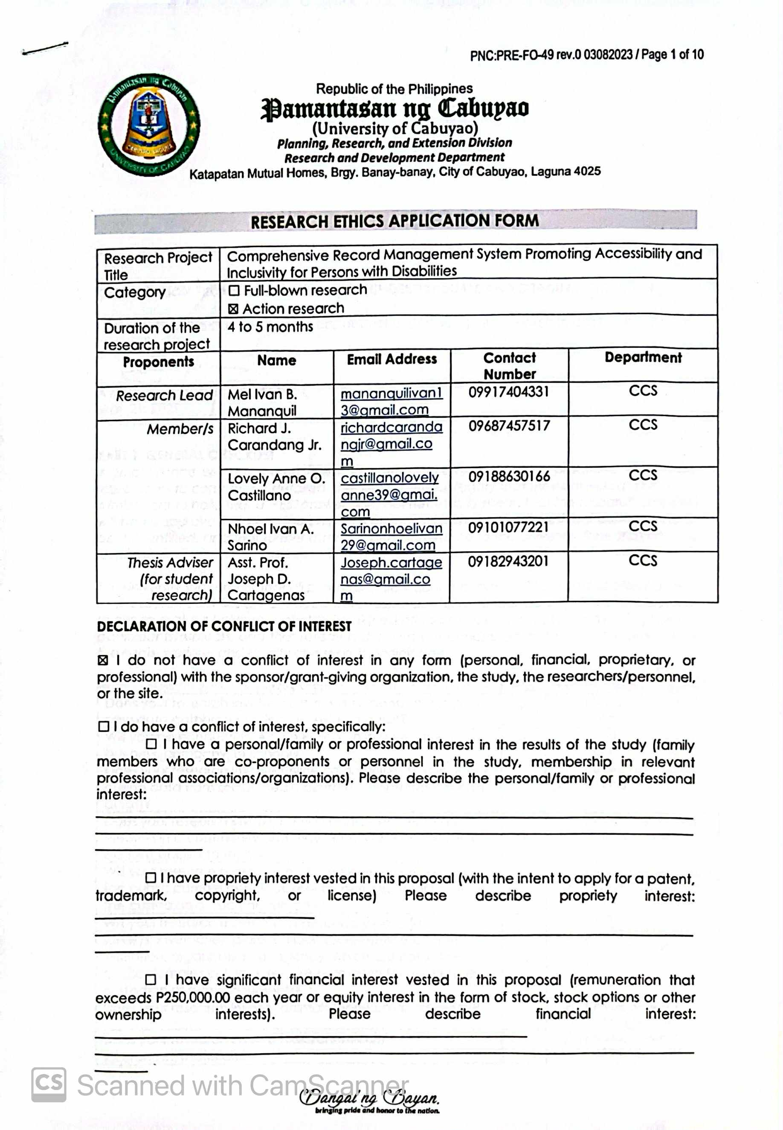**Research Ethics Review Committee Evaluation**

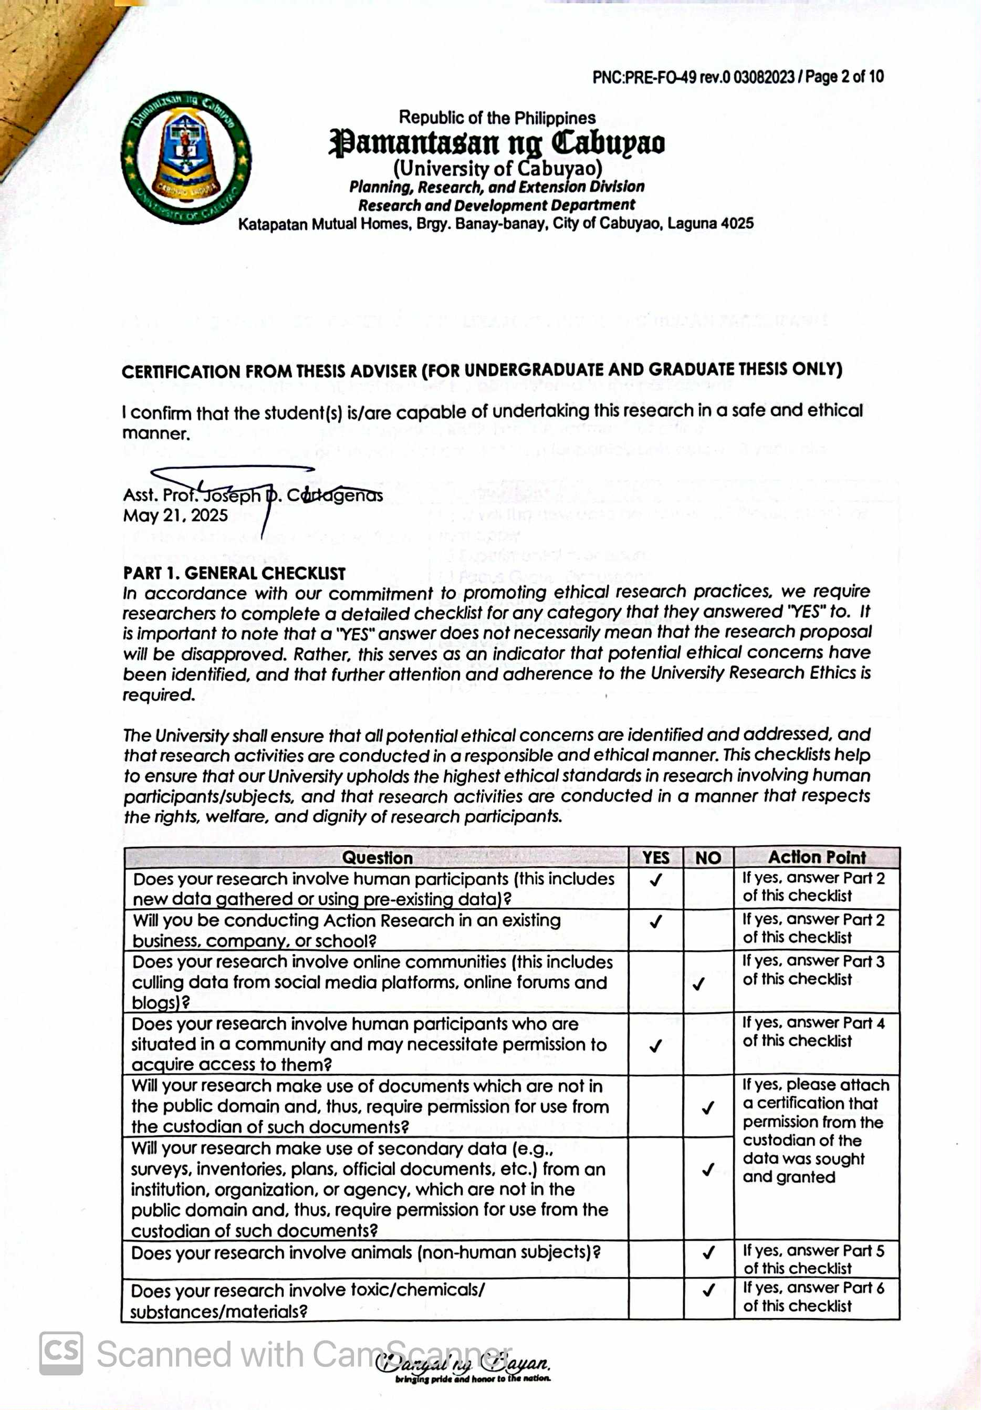

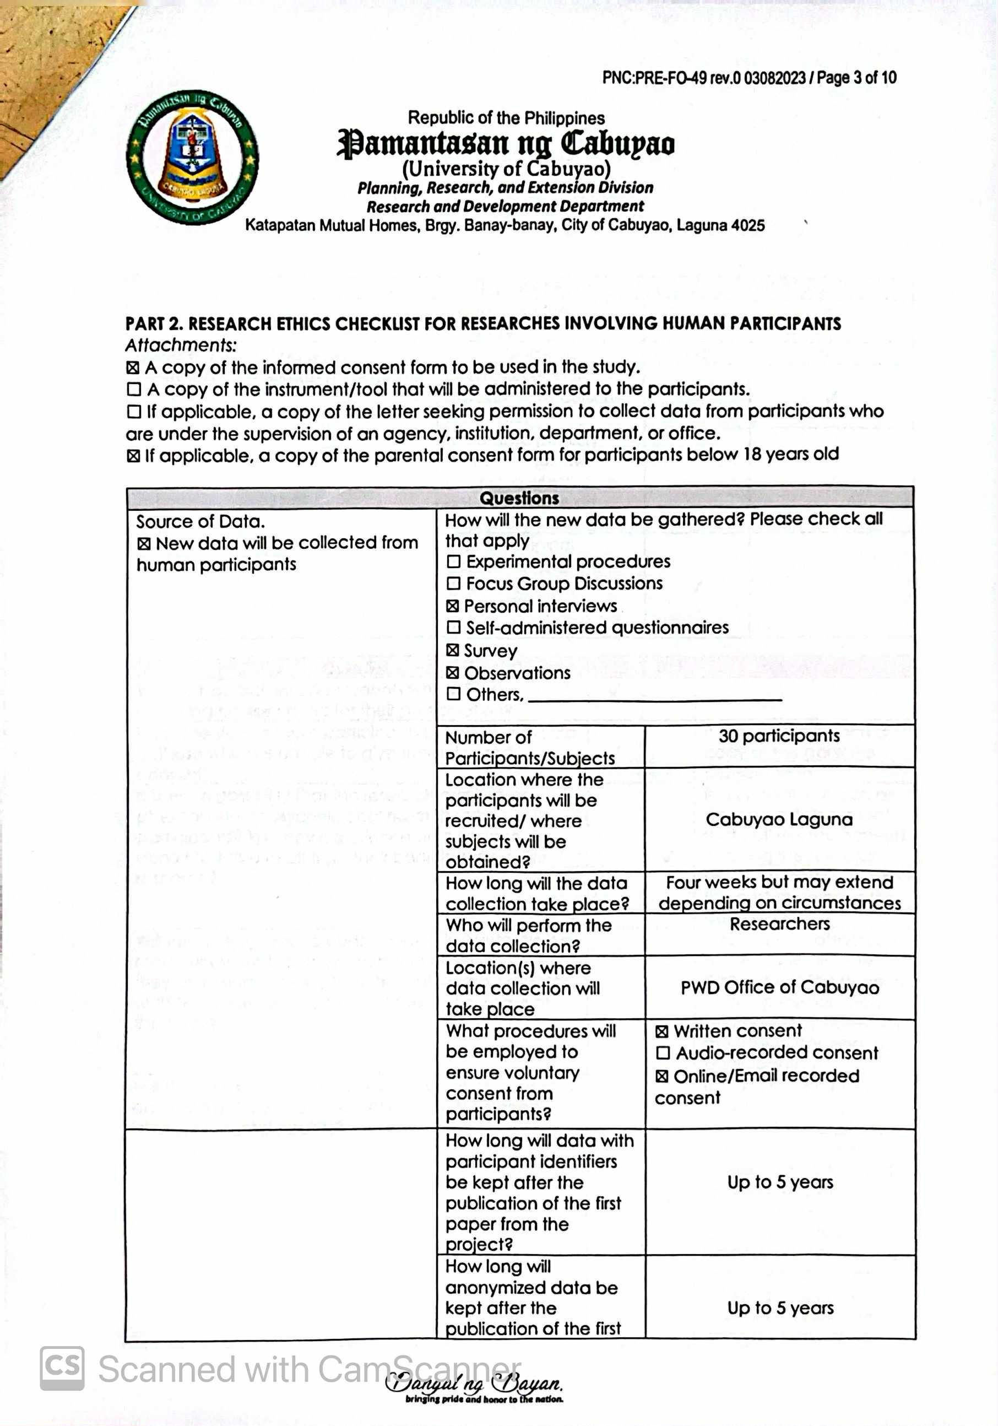

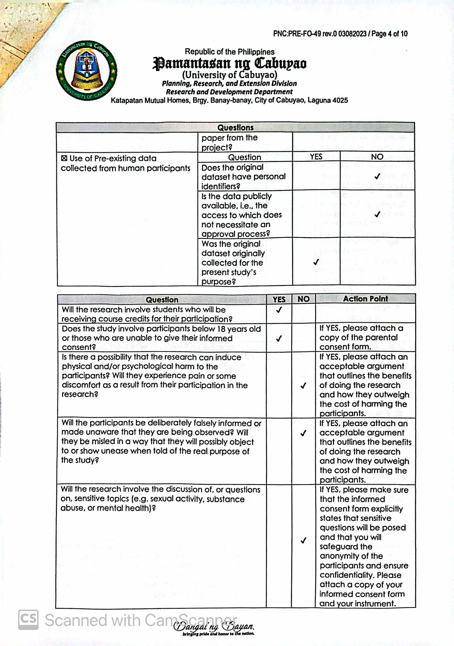

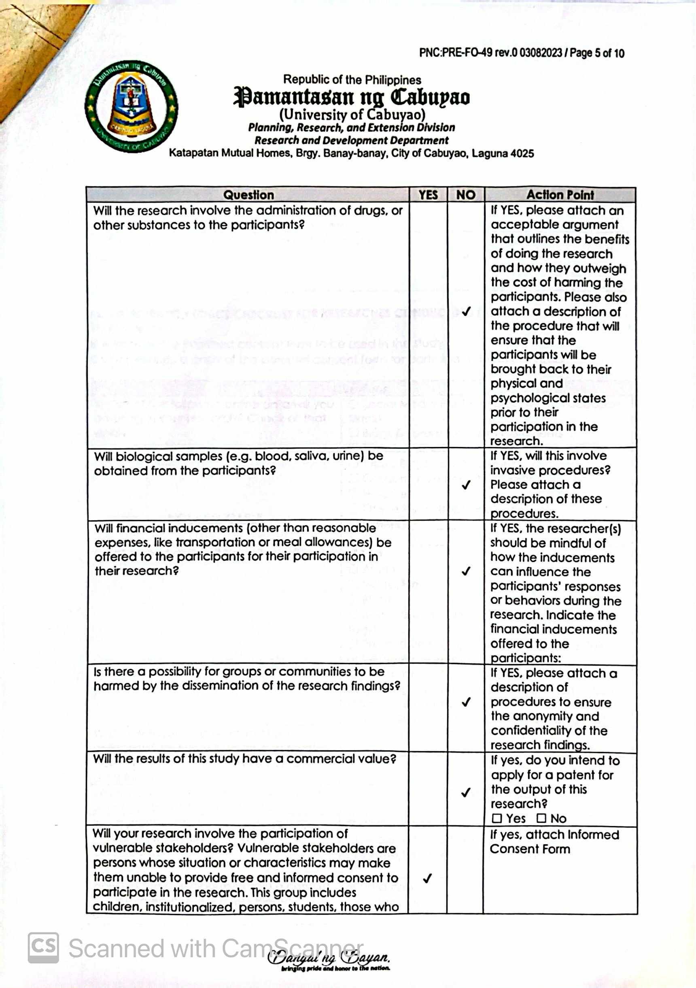

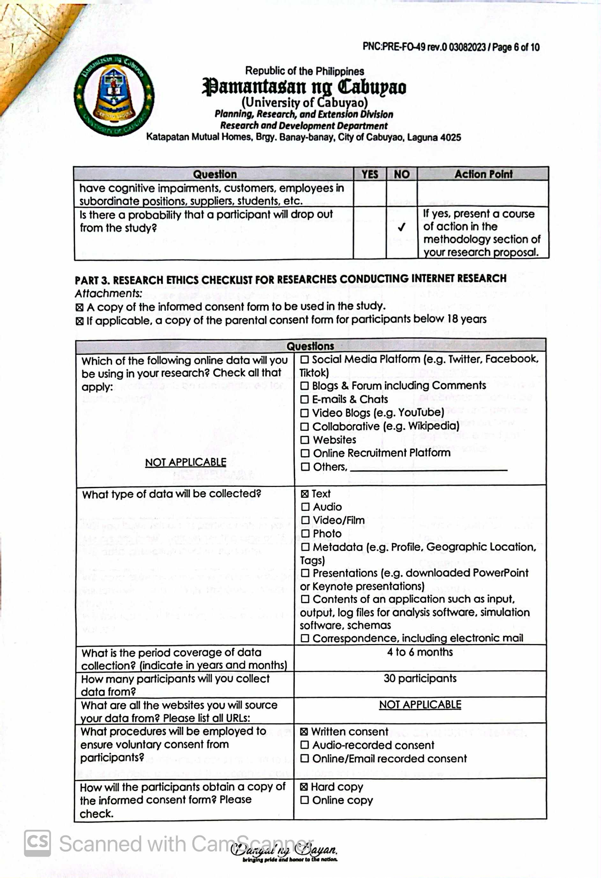

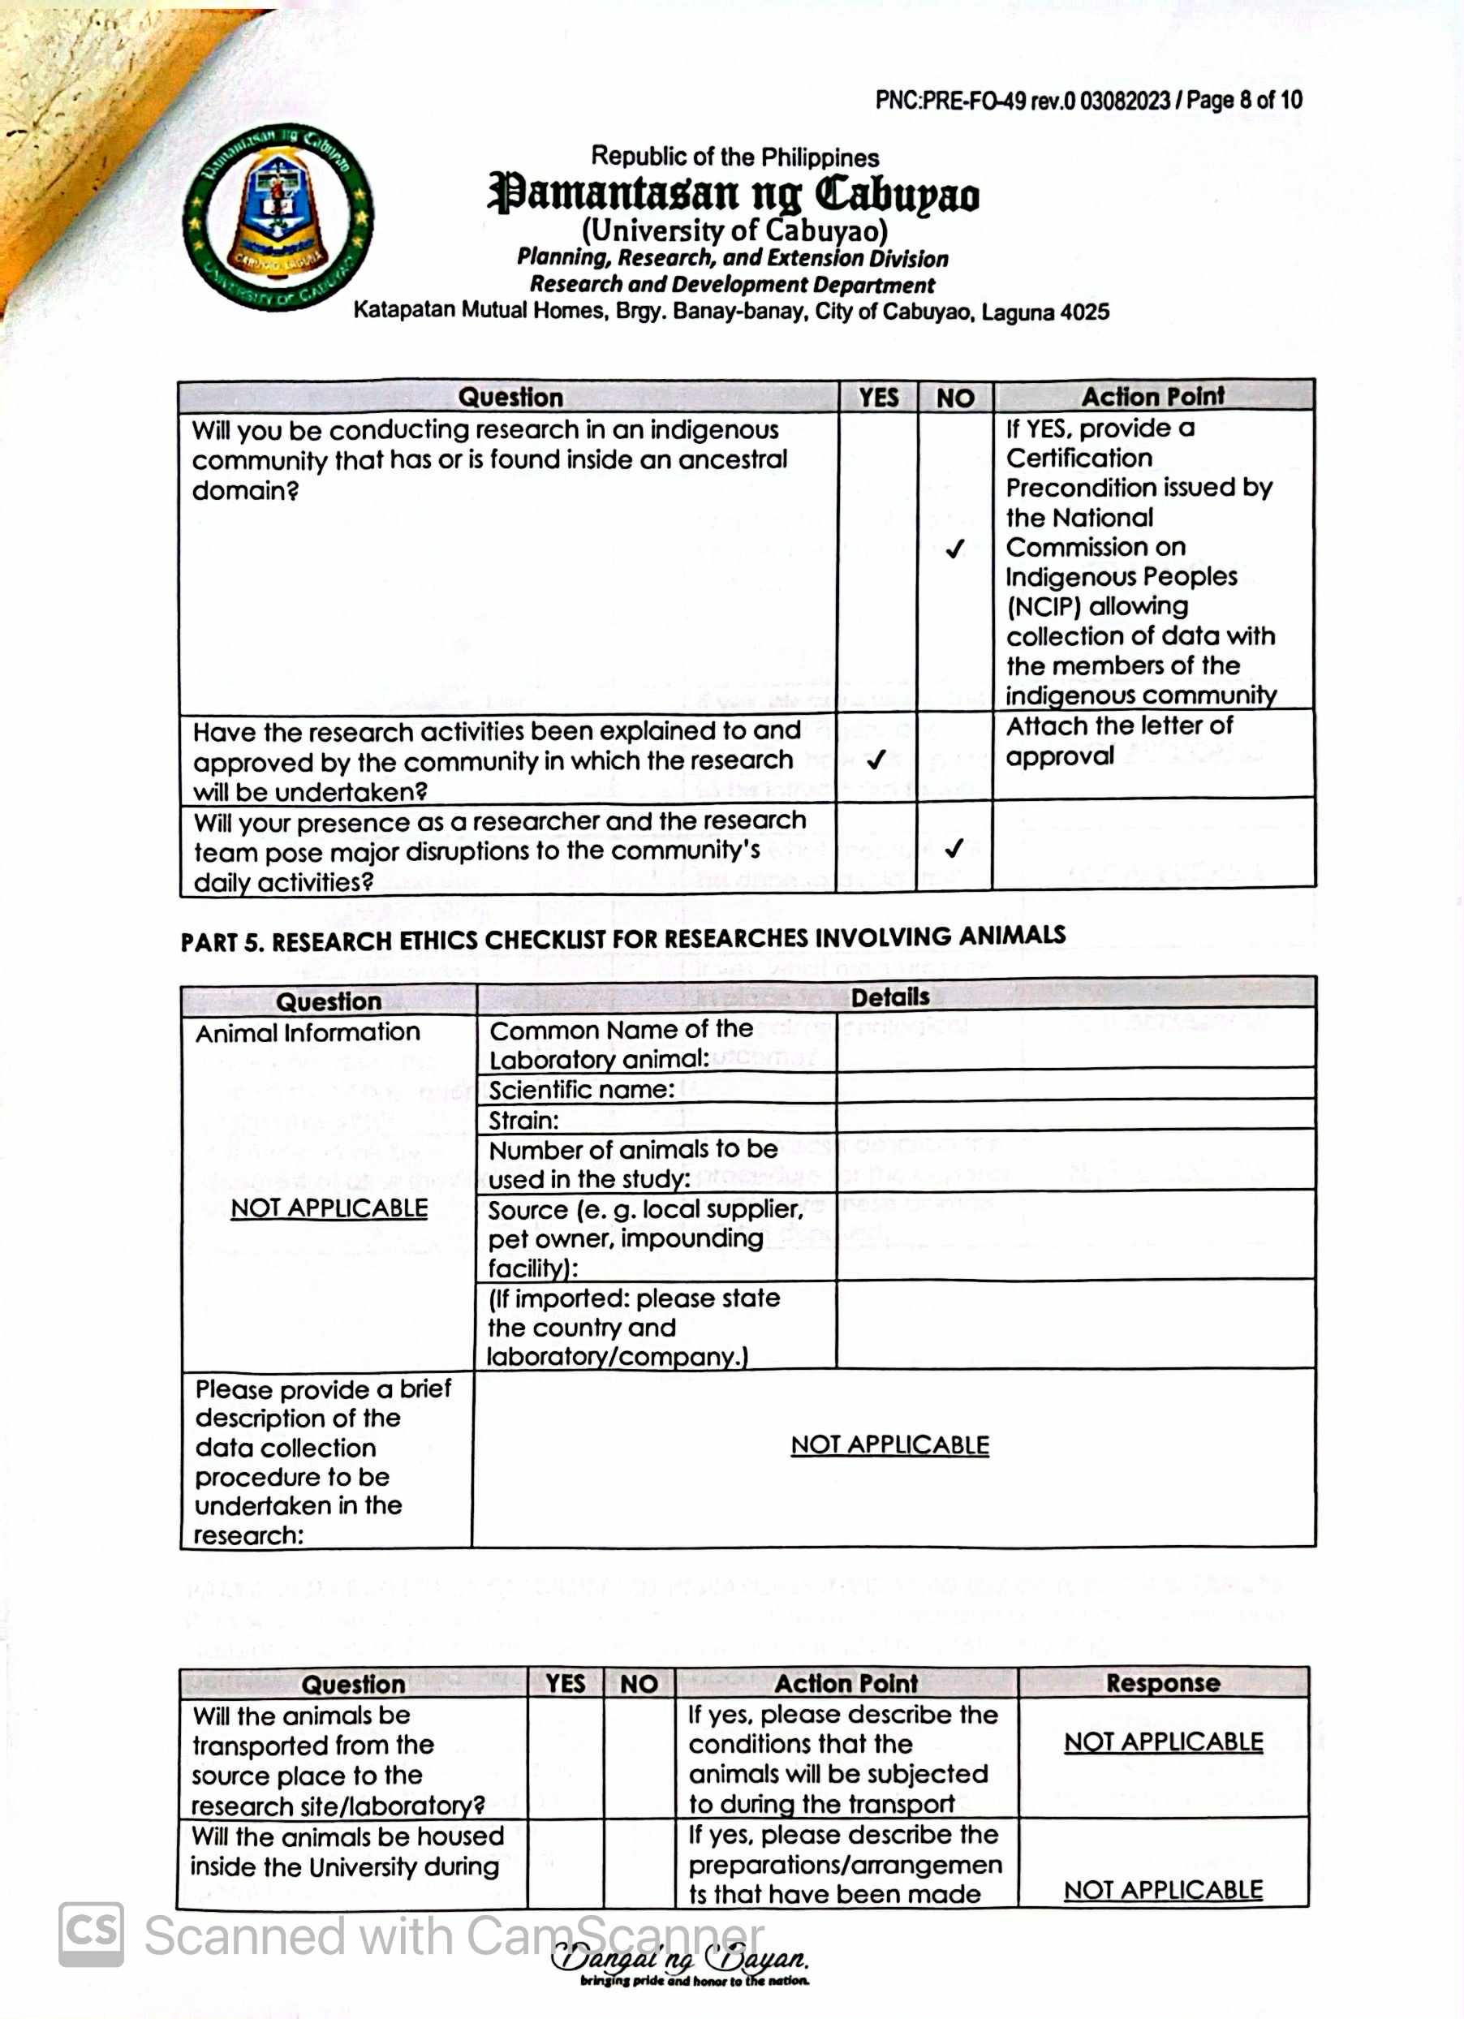

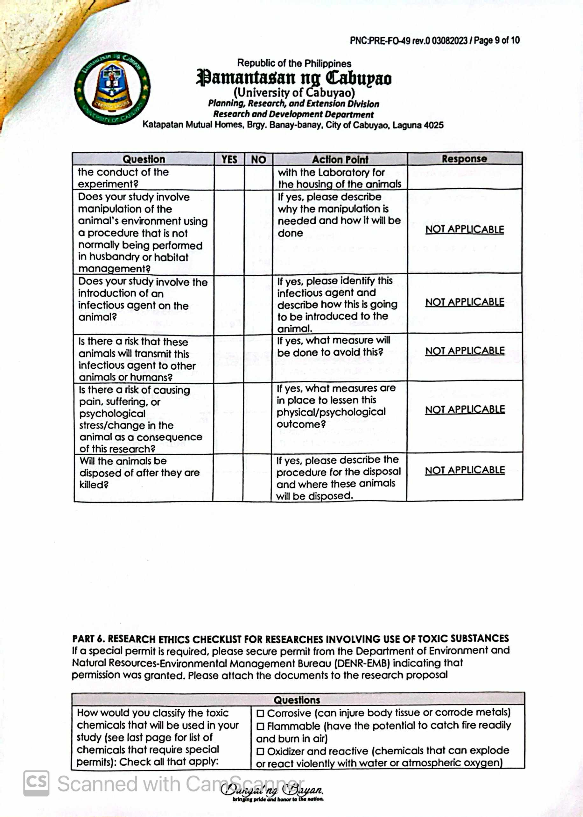

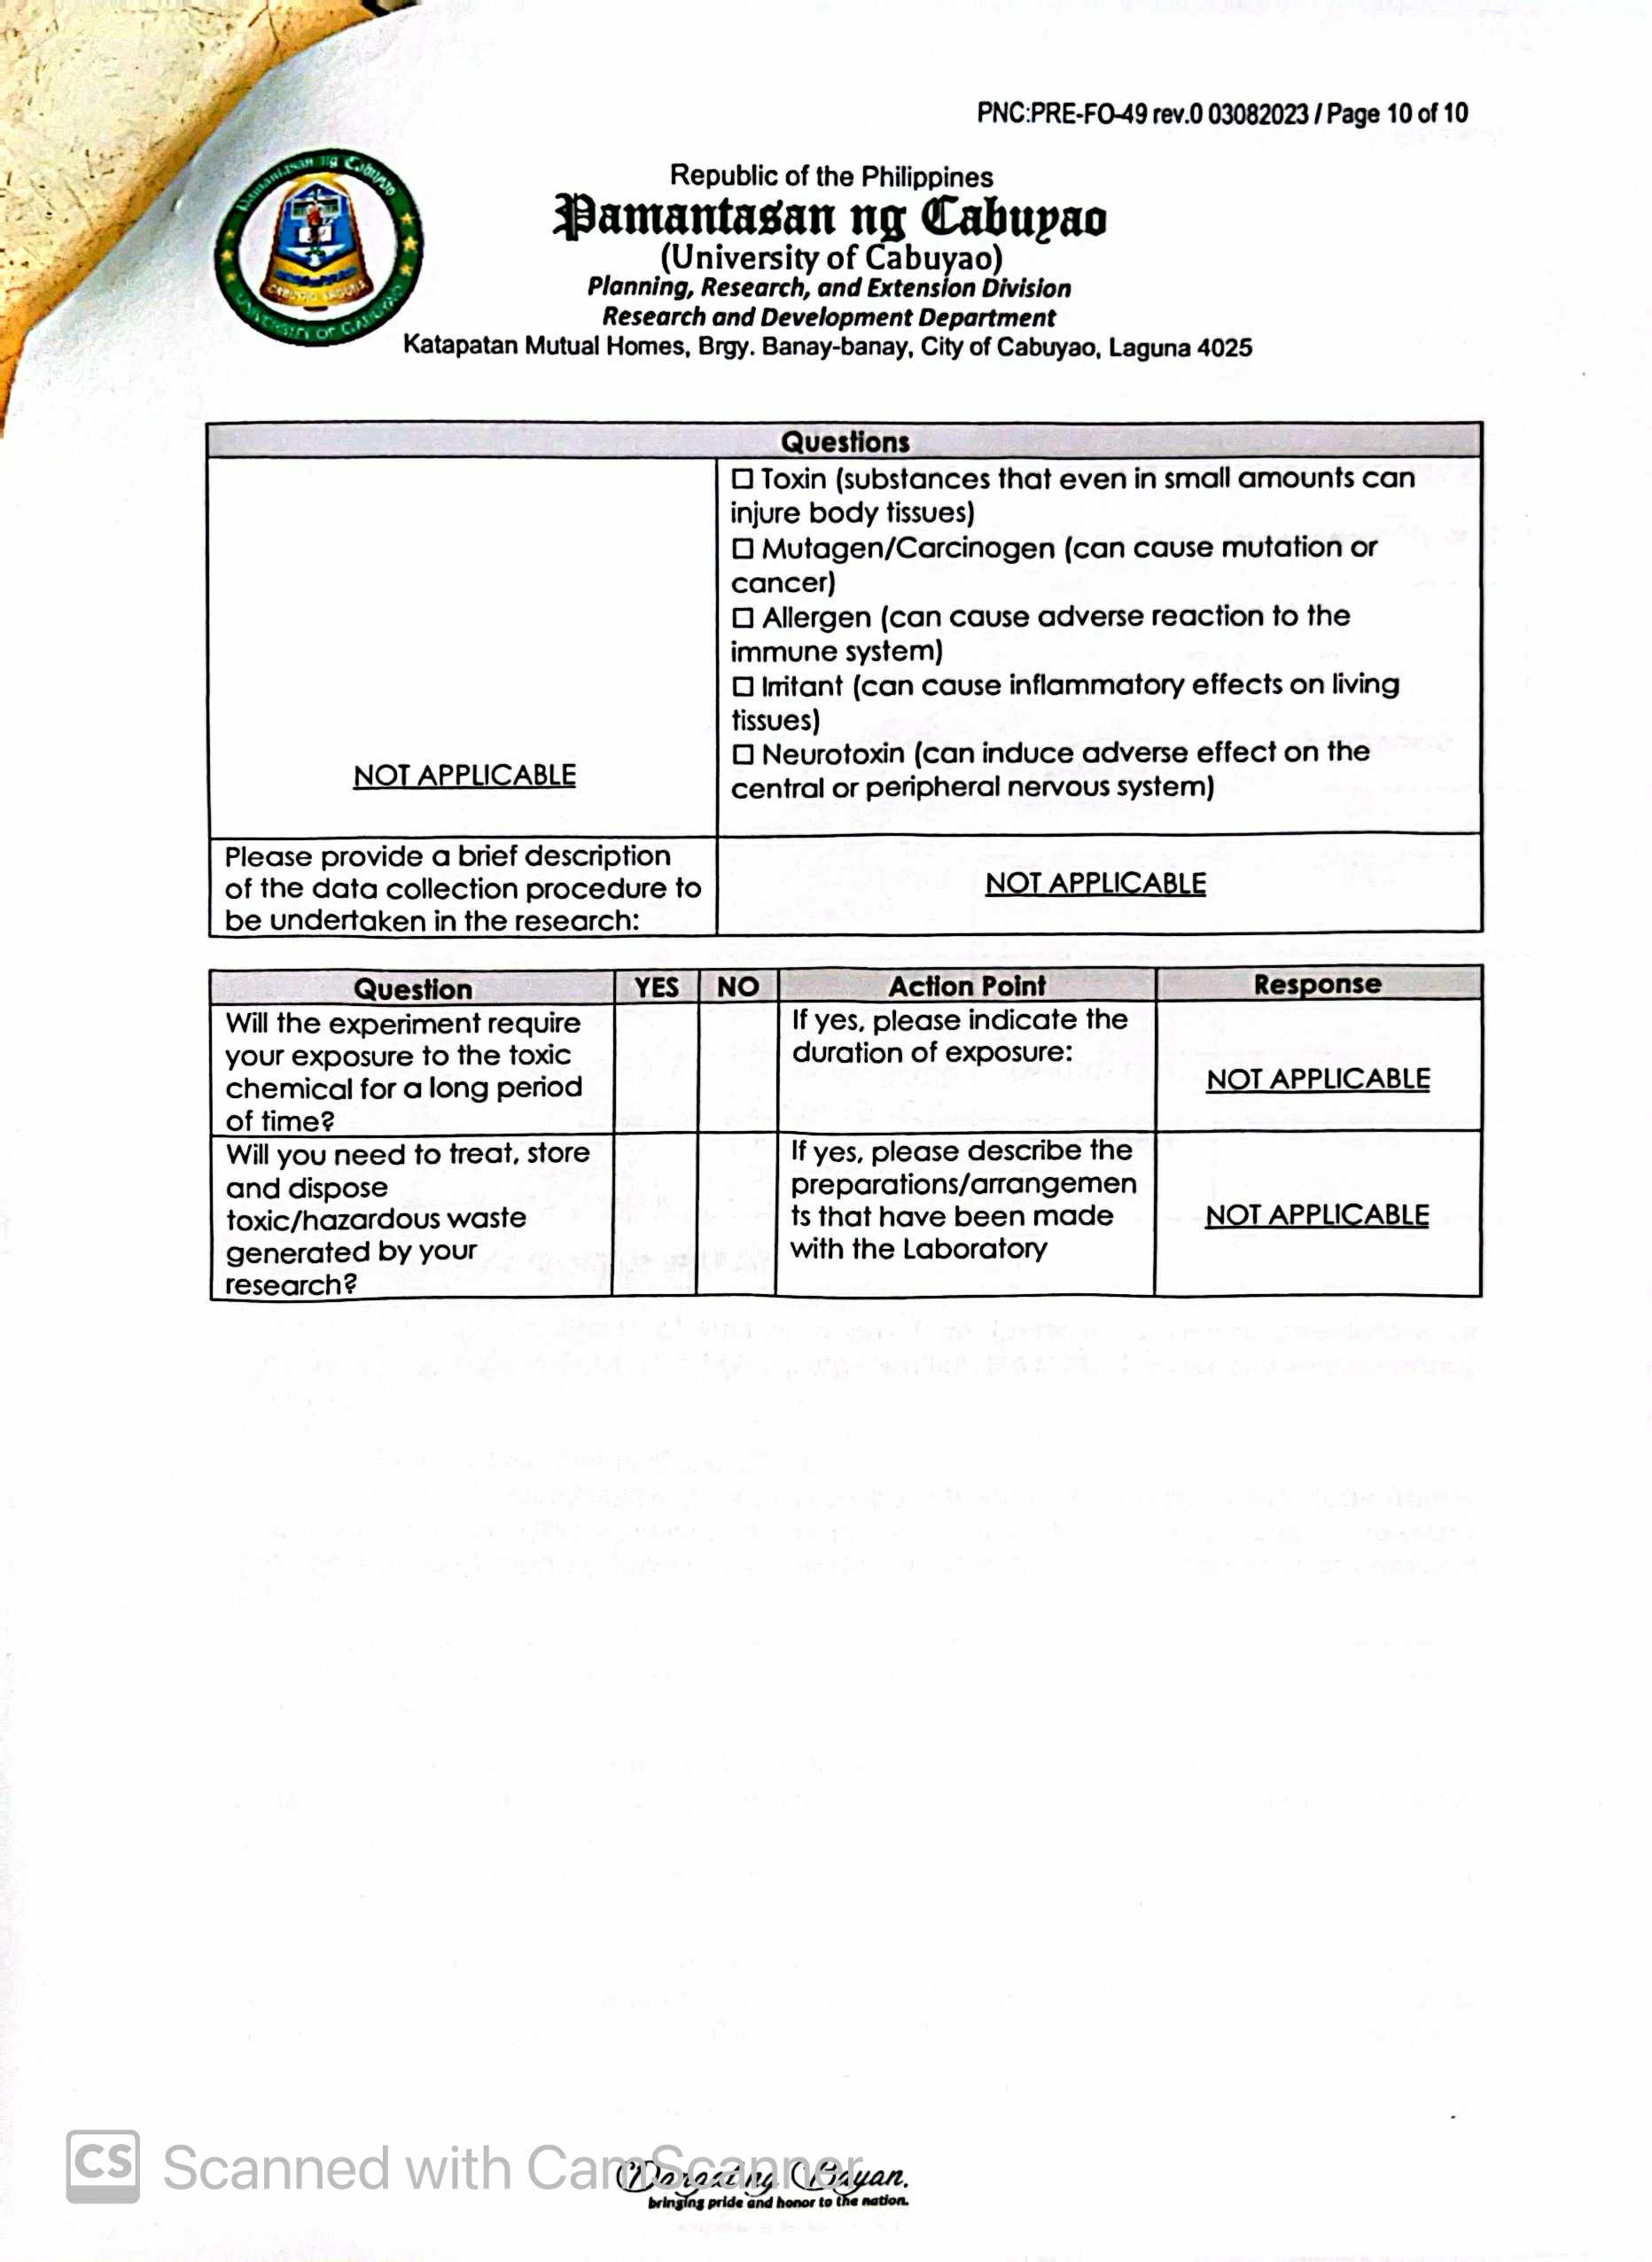

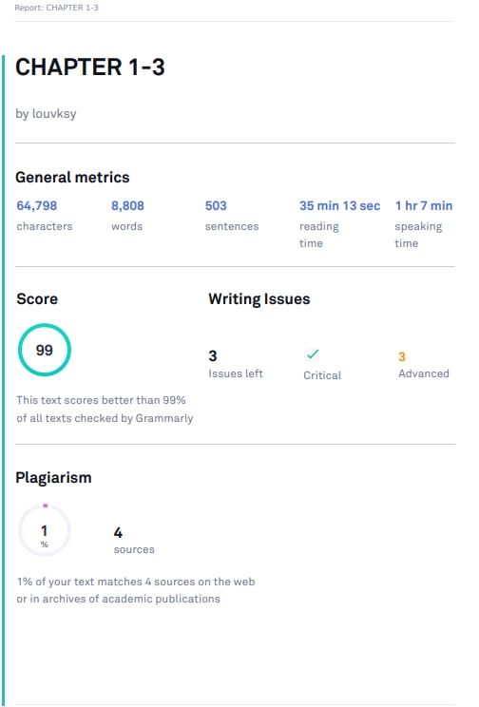**Short Report of Plagiarism Software/ Report of Language Software**

**Curriculum Vitae of Student Researchers**

